**GOVT. ARTS AND SCIENCE COLLEGE CALICUT**

**NATIONAL SERVICE SCHEME (NSS) – UNIT 17 & 107**

**ANNUAL REPORT 2022-2023**

National Service Scheme in every institution aims to educate and empower students through community service. Govt. Arts and Science College Calicut has two NSS Units with each unit comprising of 100 volunteers under the guidance of a Programme Officer. NSS Unit 17 and Unit 107 of Govt. Arts and Science College Calicut started to operate under Kabeer K.T., Asst. Professor, Dept. of Economics and Abdul Riyas K., Asso. Professor,Dept. of Zoology, as Programme Officers for the year 2022-2023. The NSS units of the college commenced the activities with the intention of enabling the students to serve the weaker sections of the society and thereby gain knowledge, leadership skills and creativity.

**13.08.2022 - Meeting**

The first meeting of NSS for the academic year 2022-2023 was held on 13.08.2022. Volunteers were given instructions regarding the activities, attendance and other related matters by Abdul Riyas K. A detailed report of various programmes conducted during the academic year is given below.

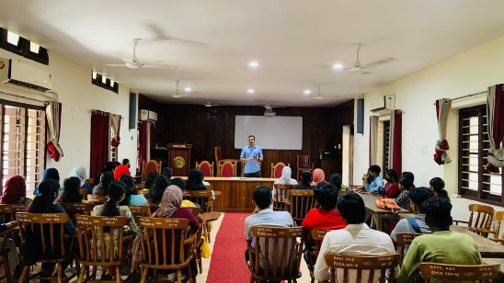 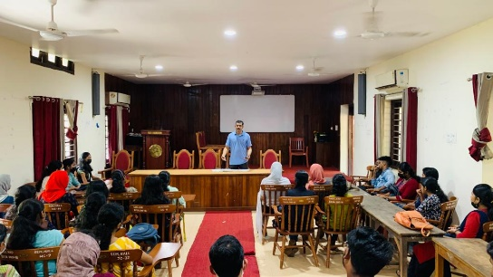

**15.08.2022- Independence Day**

Principal Dr. Edakkotte Shaji hoisted the national flag and marked the beginning of Independence Day celebrations. This was followed by the unveiling of Freedom Wall and the inauguration of Freedom Run by the Principal. RHYTHM 2022 Basic Life Support Training Class for volunteers was conducted in the college auditorium in support with Karunya Hrudayalaya, Chest Hospital Calicut and Aster Mims Hospital Calicut. Later in the day, homemade *Pothichoru* brought by volunteers was distributed to the needy ones in the Calicut Railway Station premises. In connection with the Independence Day celebrations, an Online Painting Competition on the topic “Indiayum 75 aam Swathanthrya Dinaaghoshavum” was conducted by the NSS Units. Hiba Sherin, II B.A. Arabic bagged first prize in the competition.

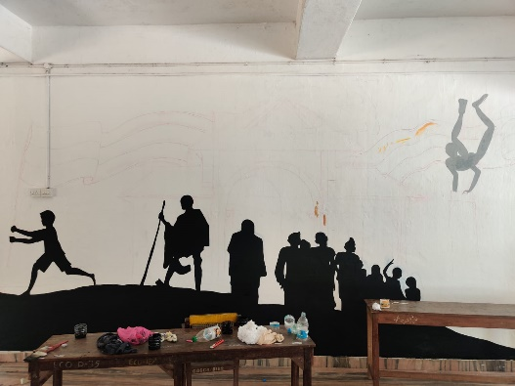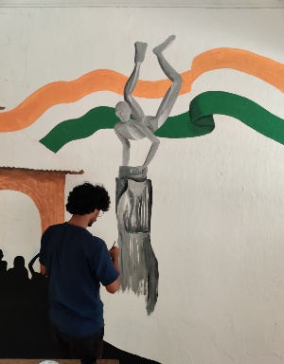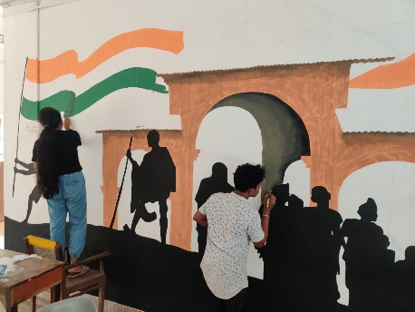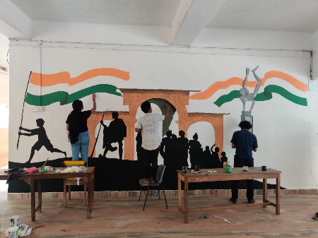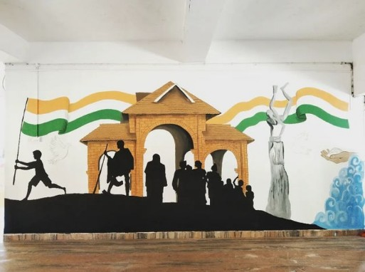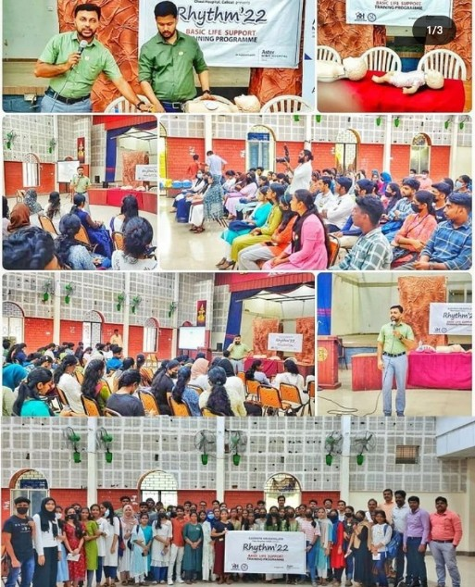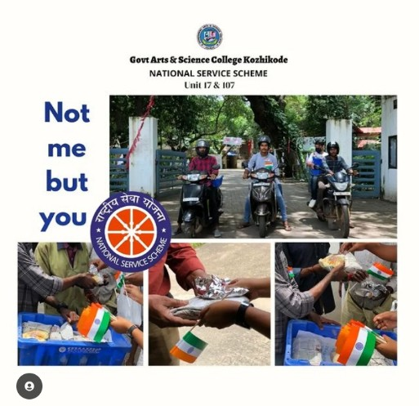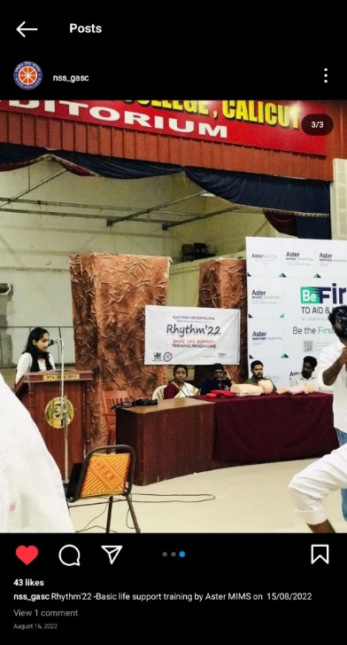

**16.08.2022- Awareness Programme**

An awareness class on the topic *Addiction and Health: Say No to Drugs* was conducted by NSS in collaboration with NCC. The class held in the Seminar Hall was handled by Dr. Anjali Viswanath, Starcare Hospital, Kozhikode. NSS Programme Officer Abdul Riyas K. Delivered the Welcome note. The programme was inaugurated by Principal Dr. Edakkotte Shaji.

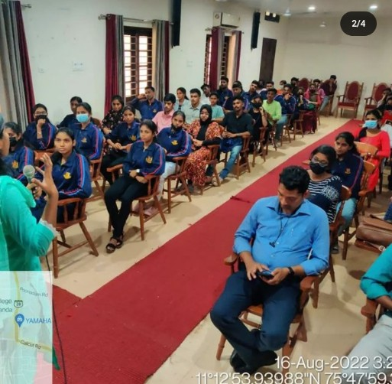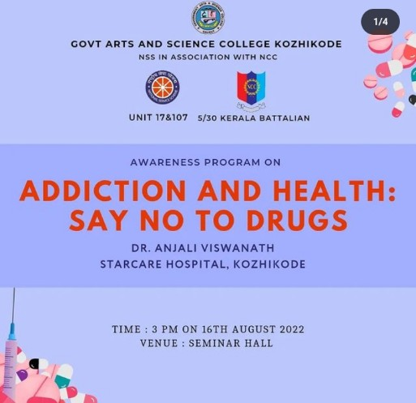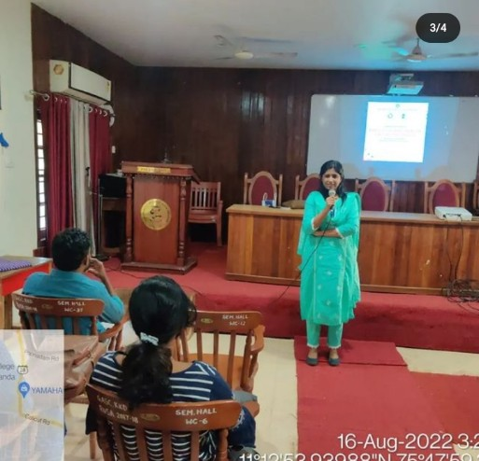

**17.08.2022- Beach Walk**

A Beach Walk was organized by the Fisheries department as part of “Shuchithva Saagaram Sundara Theeram” Campaign. The campaign aimed at transforming the sea and the beach into a plastic-free area. The Beach Walk commenced from the Beypore Fishing Harbour and ended at Beypore Beach Marina. Officials from Harbour Engineering Department, Fisheries Department and Police Department, students from Fisheries School, NSS volunteers of Govt. Arts and Science College Calicut, Members of *Theeramaithri*, *Malsyafed,* members of ESAF took part in the campaigne.

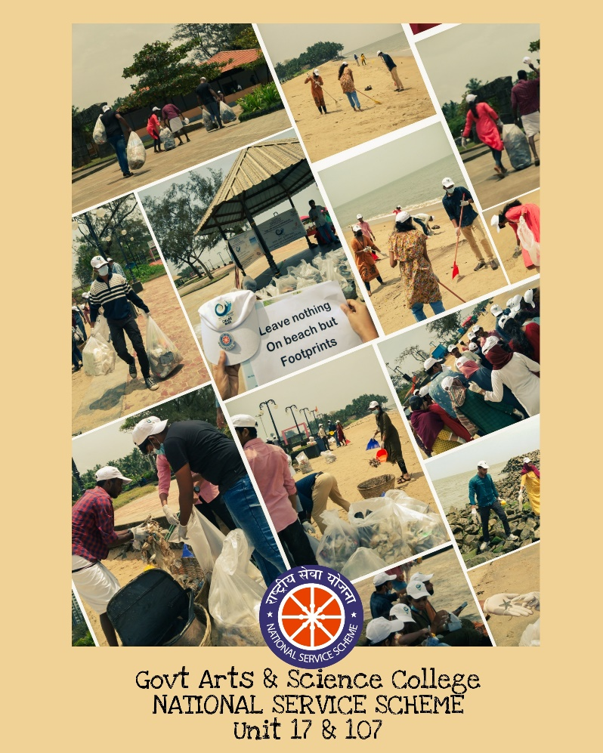

**26.08.2022- Beach Cleaning**

In connection with the *Swach Sagar Surakshit Sagar* campaigne organized by the Cochin Centre for Marine Living Resources and Ecology (CMLRE), NSS volunteers of the college participated in the beach cleaning held at Varakkal, West Hill.

**06.10.2022 – *Lahari Muktha Keralam* (Anti Drug Awareness Programme)**

An awareness programme against drug abuse was organised. A College level Anti Drug Quiz Competition was also conducted in the Science Seminar Hall. Sreebhavya T. (II BSc Zoology) won the first prize in the Quiz. Ambili Sreeni K., (II BSc Zoology), and Bidhun C. ( I BSc Maths) attained the second and third positions respectively.

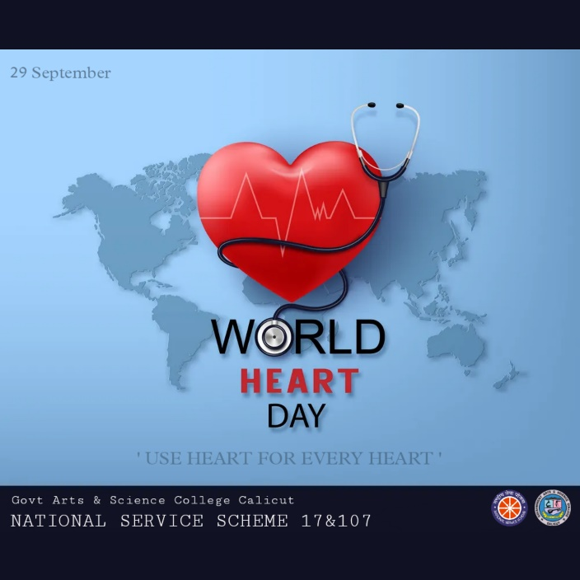

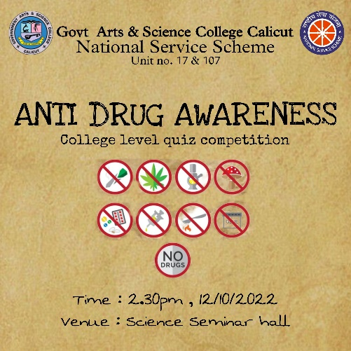 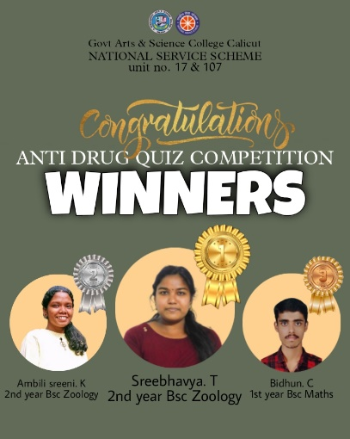

**24.09.2022 – NSS Day**

NSS Day was celebrated on a grand scale by the two units on 24.09.2022. The day commenced with the NSS song. Principal Dr. Edakkotte Shaji inaugurated the programme and NSS Programme Officers Abdul Riyas K. and Kabeer K.T. interacted with the students. A Notice Board titled “NSS” was created and later in the day students formed groups and cleaned the college and the premises. Volunteers spent the rest of the day sharing sweets and singing songs.

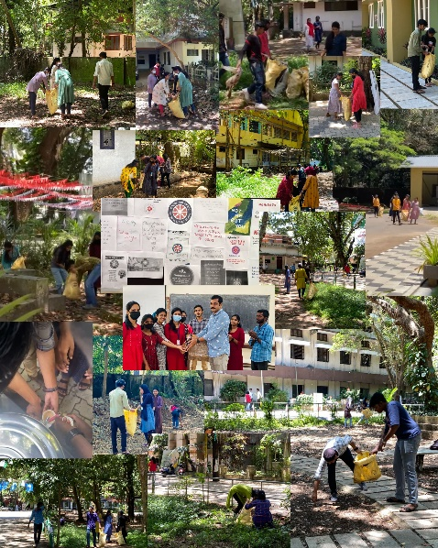

**27.09.2022 – World Tourism Day- Field Trip to *En Ooru***

NSS volunteers College of Unit 17 & 107, Govt. Arts & Science went on a field trip on World Tourism Day. The Trip was to Kerala’s first ever tribal village, *En Ooru,* Wayanad. The team of 44 students were accompanied by the Programme Officer Abdul Riyas K.

The trip was a refreshing and enriching experience for the volunteers as they got to acquire knowledge on the tribal history of Wayanad. The volunteers could get a taste of indigenous culture and tradition. The team also visited Thusharagiri Waterfalls on their way back.

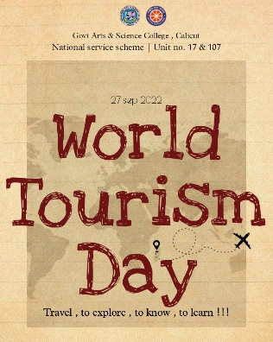 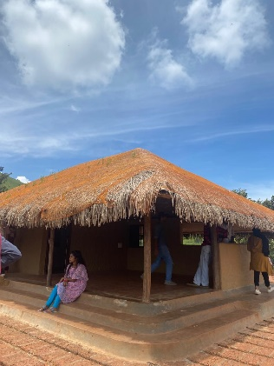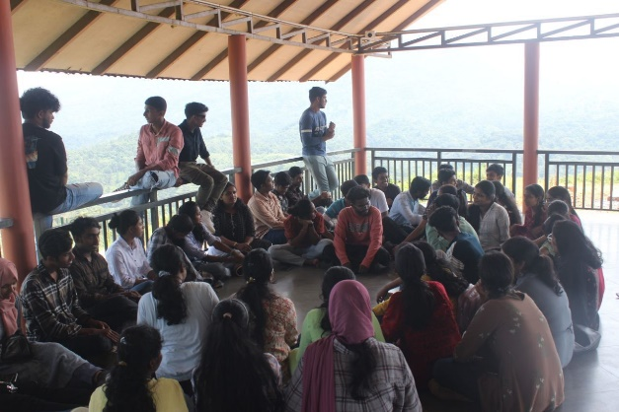 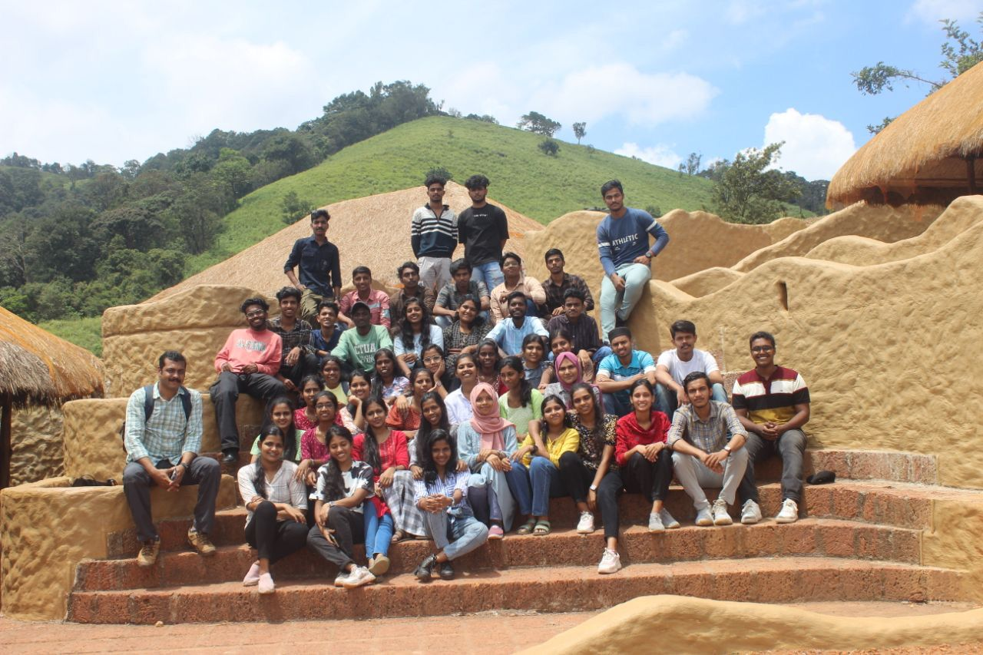

**29.09.2022- Blood Donation Camp**

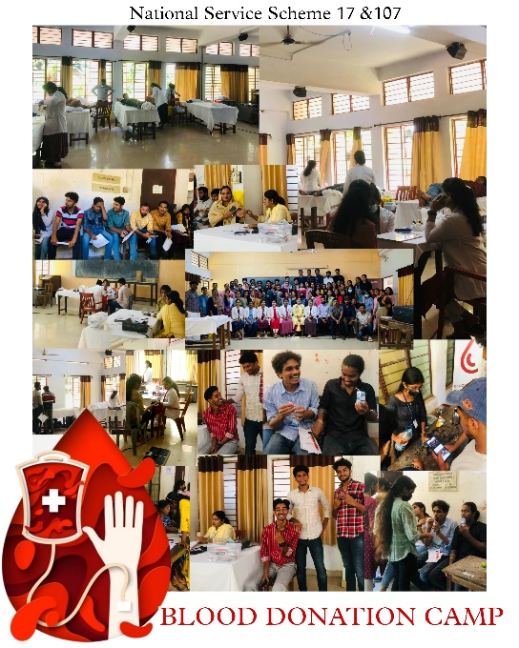

The NSS Units of the college in association with *Chiraku Charitable Trust* and *Meitra Hospital Calicut* conducted a Blood Donation Camp on the occasion of World Heart Day.The camp held in the college on 29.09.2022 from 10.00 am to 3.00 pm was a huge success owing to the participation of students, teachers and non-teaching staff who selflessly joined the noble cause. Out of 99 registrations, 55 donated blood and made a vital contribution towards community service.

**13.10.2022 – Meeting**

A meeting of all volunteers and the two Programme Officers was convened to give instructions related to work and to discuss the future activities of the units.

**17.10.2022 – Road Safety Awareness Programme**

The Closing Ceremony of the 8 day long Road Show, a Road safety Awareness Programme organised by Aster Medcity was held at Govt. Arts & Science College Calicut. On the occasion of Trauma Care Day, the team visited the college and gave a demonstration of scientific life-saving methods and technics to be adopted during road accidents. Dr. Venugopal (Aster Mims Emergency Head), Dr. Ajitha Kumari (Corporation Councillor Kozhikode), Ajith Balan (Assistant Officer), and Abdul Riyas K. (NSS Programme Officer) graced the occasion and interacted with the students.

**20.10.2022 – White Cane Awareness Seminar**

Every year, World White Cane Day is celebrated on October 15 to recognise the importance of white canes for blind people to assure their safety and freedom. Kerala Federation of the Blind Youth Forum and the NSS units of the college jointly conducted a White Cane Awareness Seminar in the college. The Seminar was held on 20.10.2022 at 2.00 pm in the college seminar hall. The seminar was inaugurated by Kunji Moyin Kutty, Assistant Commissioner of Police, Kozhikode. C.K. Sathyasheelan ( Vice President, Kerala Federation of the Blind), K. Nalin ( Software Developer), Ansar Ponnani ( Joint Secretary, KFB Youth Forum) participated in the programme. The seminar could successfully communicate the importance of white cane in the lives of visually impaired people and create awareness among the students.

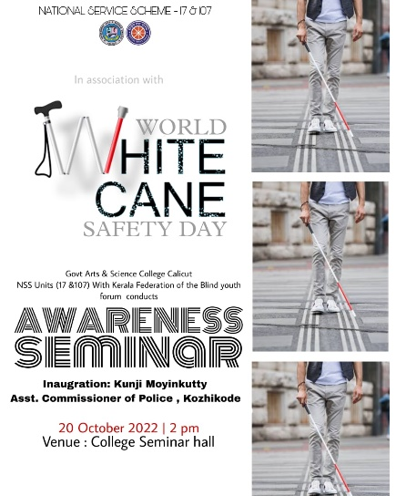 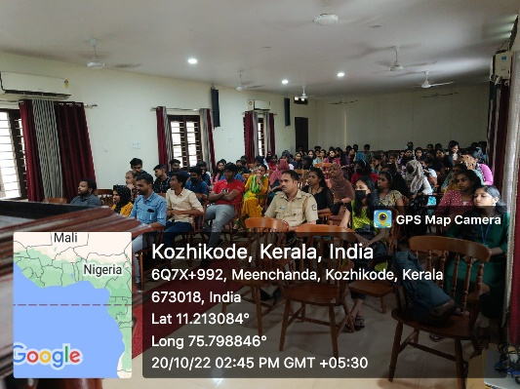 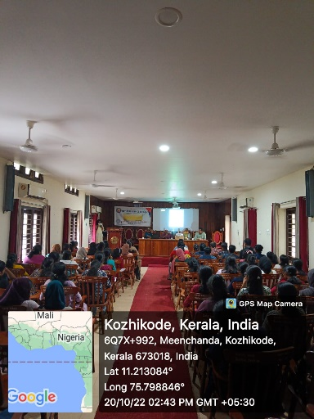

**21.10.2022 – NAAC Felicitation**

The State government conducted an event on October 21 to felicitate Calicut University for securing ‘A plus’ grade in the ranking by the National Assessment and Accreditation Council (NAAC). NSS volunteers from the

College participated in the Celebrations held at Calicut University.

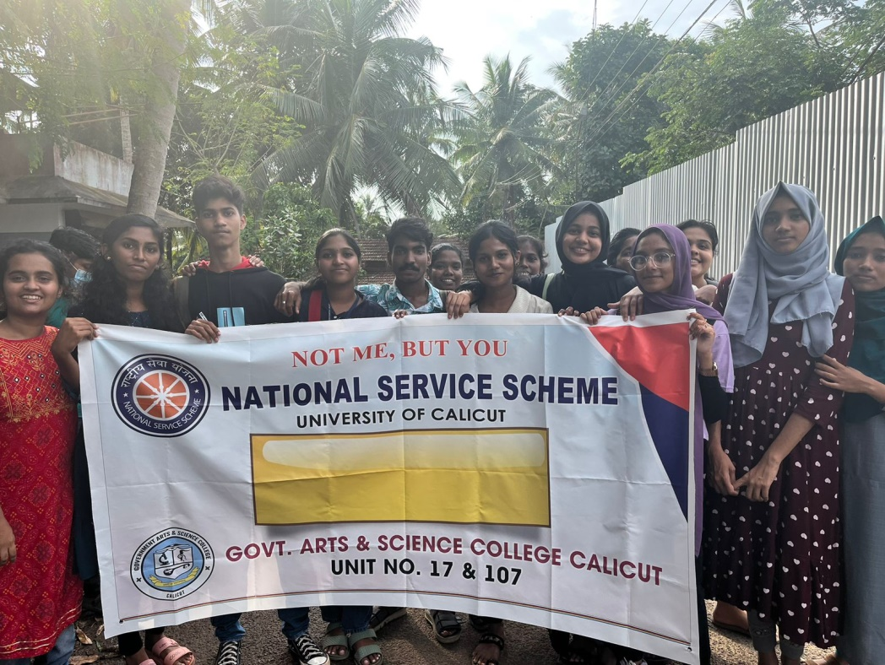

**01.11.2022 – *Kerala Piravi* Celebration**

NSS volunteers of unit 17 & 107 became a part of *Kerala Piravi* celabrations held in the college. The volunteers joined the “*Pada Yatra”* to create awareness against Drugs on the same day. Later in the day various cultural programmes were conducted.

**18.11.2022 – Meeting**

A meeting of NSS volunteers was convened on 18.11.2022 to discuss the details of the upcoming Nature Camp, attendance, and future activities of the units.

**18.11.2022 – College Union Election**

The students volunteered during the College Union Election from 9.00 to 5.00 pm. The volunteers ensured the smooth conduct of the election.

**21.11.2022 & 22 .11.2022 - Nature Camp- Wayanad Wild Life Sanctuary**

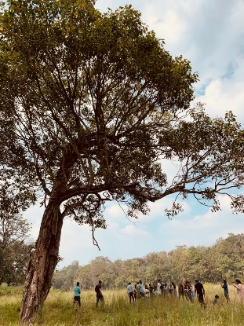 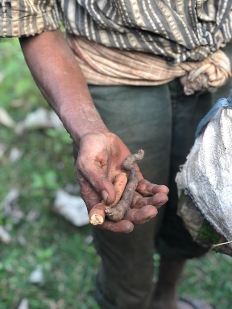 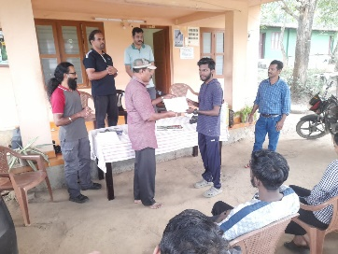 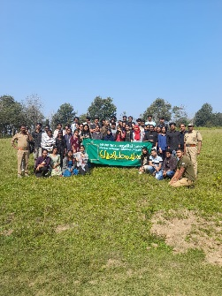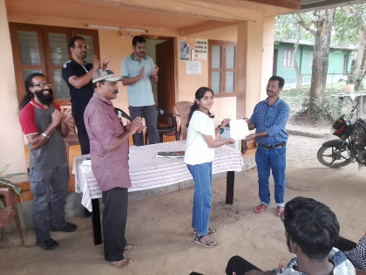 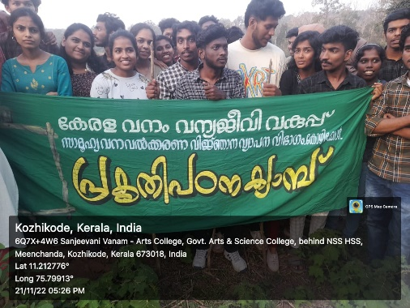 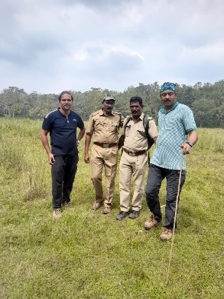

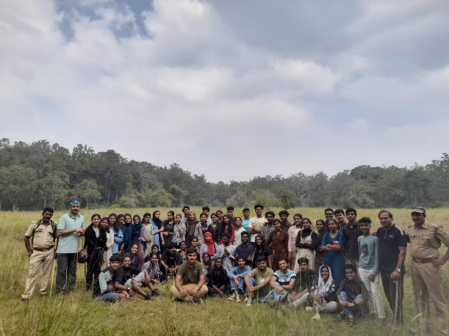

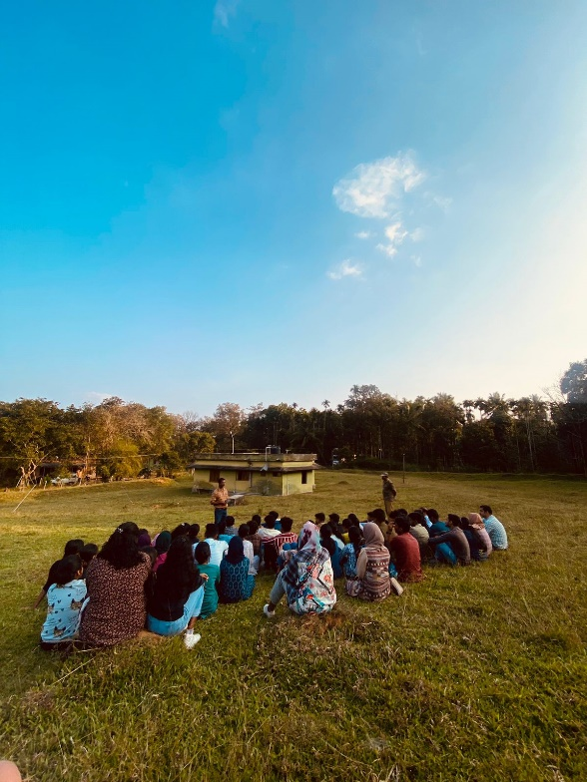 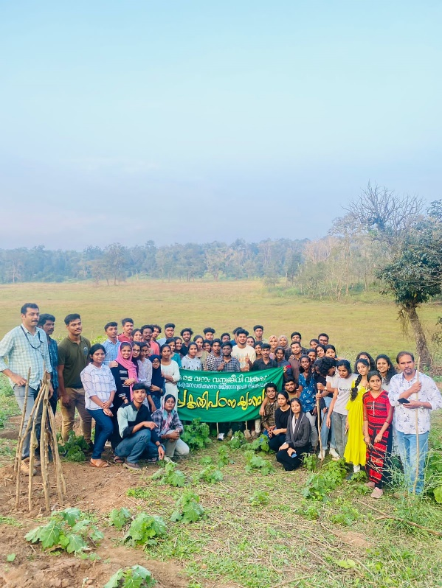

A two day Nature Camp was organised for the volunteers at Wayanad Wildlife Sanctuary on 21.11.2022 & 22 .11.2022. 58 volunteers attended the Nature Camp with the two Programme Officers and a lady teacher from the college. It was a very enriching experience for the volunteers to explore nature and also to mingle with each other and grow together as a community.

**23.11.2022 – Selection**

The selection process of the first year students was held on 23.11.2022 afternoon. The selection procedure involved an Examination (MCQ), Field work, and Interview. The half an hour exam was in Multiple Choice format. Students were divided into 12 groups and field work was monitored by the teachers. Students were interviewed by the Programme Officers on the same day. Another interview was conducted by the class tutors on the following day.

The selection committee was very keen to include the most deserving and potent candidates based on the results of evaluation.

**05.12.2022 – World Volunteers Day**

On the occasion of International Volunteers Day, volunteers cleaned the college. This was the first activity assigned to the newly admitted first year volunteers. Students were given a basic idea about the role of National Service Scheme in community service. It was an opportunity for the newly admitted students to socialise with the senior volunteers. The programme commenced at 10.30 am and ended at 1.00 pm in the afternoon.

**22.12.2022 – International Day of Persons with Disabilities**

International Day of Persons with Disabilities is observed every year on 3 December. NSS Units 17 and 107 and Barrier Free Campus of the college together hosted an event to celebrate the International Day of Persons with Disabilities. “Phoenix”, an endeavor to support and encourage differently abled children was inaugurated by the Chief Guest Dr. Fathima Asla (Pathumma). Dr. Fathima Asla led the Seminar organised to discuss the ways in which campuses can be made disability-friendly. A Digital Library comprising of a wide range of audio books for the disabled was inaugurated by the Principal Dr. Edakkotte Shaji. An exhibition was also arranged by Mr.Yousuf Changorath to create awareness on the topic. Articles related to differently abled students, their craft works and books on the topic were displayed in the exhibition. “Phoenix” operates in the campus under a Student Director. The activities of the programme include various services for the differently abled students in the institution like arranging Scribe, helping them with everyday activities etc.

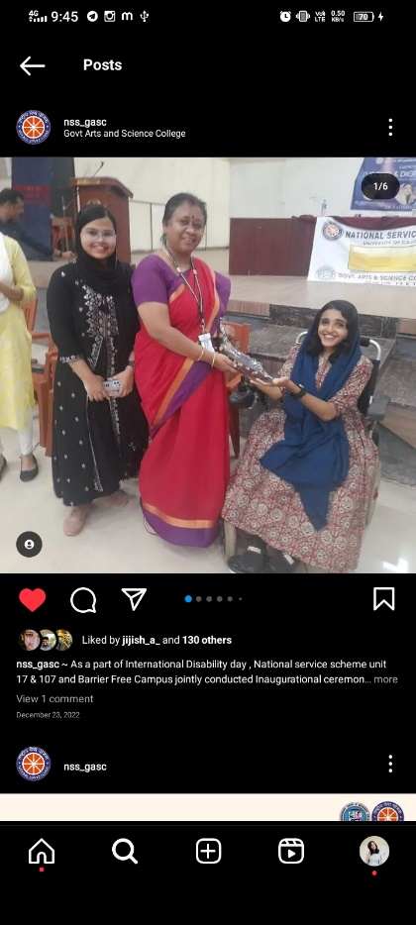 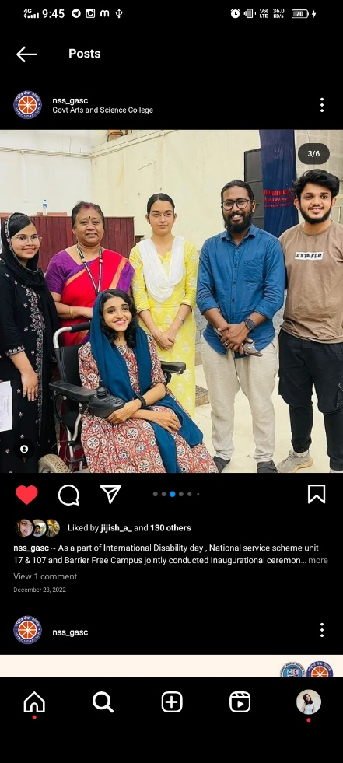 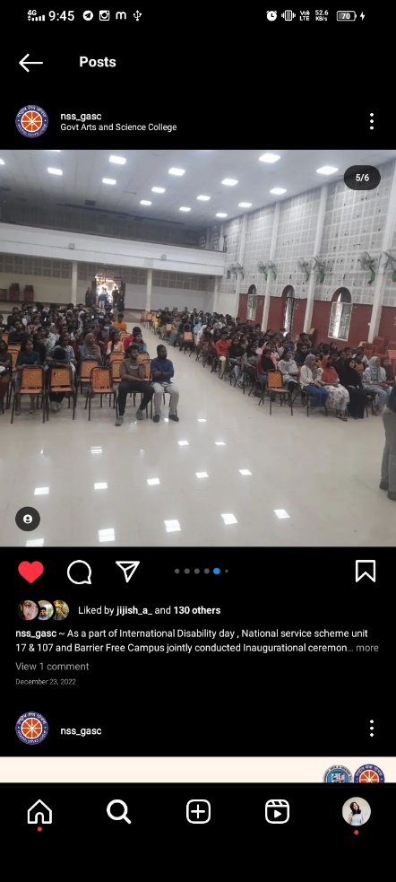

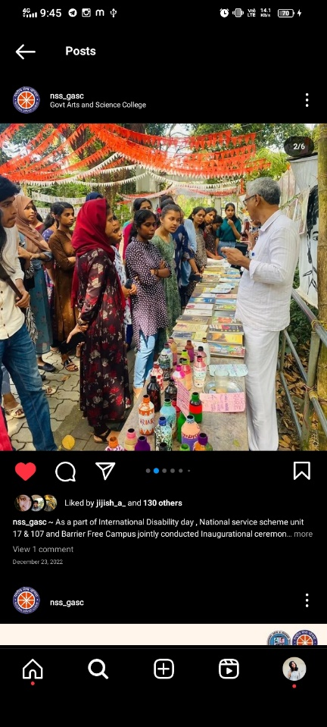 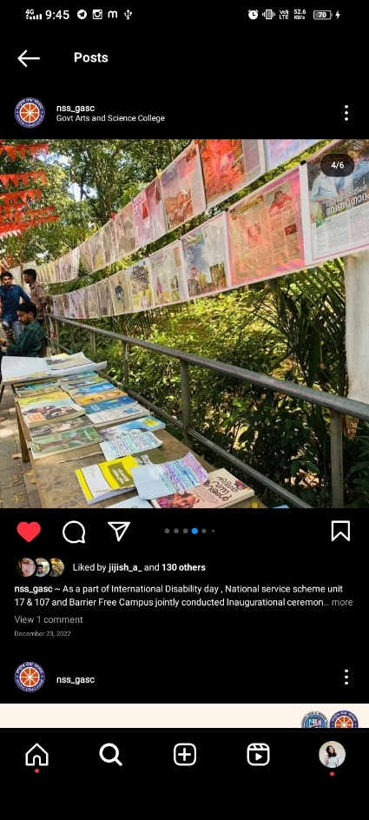 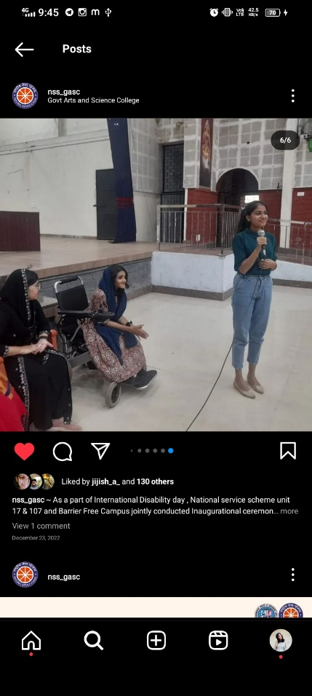

**26.12.2022 - 01.01.2023 – NSS Special Camp**

The 7 Day residential camp for the volunteers of Unit 17 & 107 was held at MGM Higher Secondary School Engapuzha from 26.12.2022 to 01.01.2023. “Lahari Muktha Youvanam” was the theme of the camp for the academic year. The 7 day camp named “Kutturuvam” was a learning experience for the volunteers that helped them grow and evolve as responsible citizens dedicated to social service.

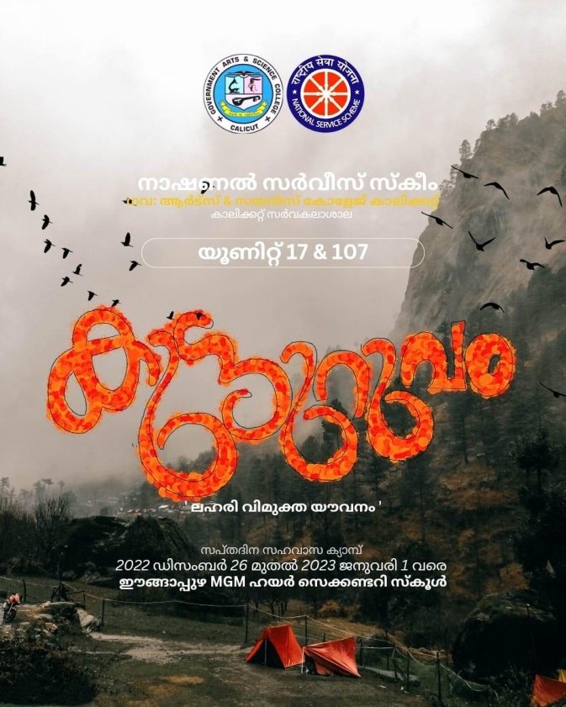

The official inauguration the camp was done by Mr. Abdul Latheef Cholakkal (DFO, Kozhikode Forest Division). Kabeer K.T. (Programme Officer) delivered the Welcome Address for the function. The Keynote Speaker was Smt. Beena Thankachan ( President, Puthuppady Grama Panchayat). Felicitations were delivered by Suneer K.P. (Kozhikode District Panchayat Member), Amal K.P. (Puthuppady Grama Panchayat Member), Alex Mathew C. ( Principal , MGM Higher Secondary School Engapuzha), Reni Varghese (HM, MGM High School Engapuzha), Fr. Baby John Kaleekkal (MGM Higher Secondary School Engapuzha), Dr. Mini E. ( Vice Principal, Govt. Arts & Science College Calicut), Dr. U.K.A. Saleem ( Staff Council, Govt. Arts & Science College Calicut), Mini V.M. ( PTA Vice President, Govt. Arts & Science College Calicut ), Rajeevan K. (Forest Range Officer Thamarassery), and Mujeeb Thalappoyil ( PTA Member, MGM Higher Secondary School Engapuzha). The Vote of Thanks for the function was delivered by Nayana J. (NSS Volunteer Secretary).

After the inaugural ceremony, an Ice-Breaking session was conducted for the camp members by Shafi Pulpara (NSS District Coordinator).

The activities of the volunteers over the seven days include Wayand Ghat Cleaning, Check Dam Cleaning, Vanaparvam Cleaning, Health Survey,Medical Camp, Cleaning School Garden and premises. Resource Persons from various

fields like Theatre, Folk Arts, Martial Arts etc. handled sessions for the volunteers.

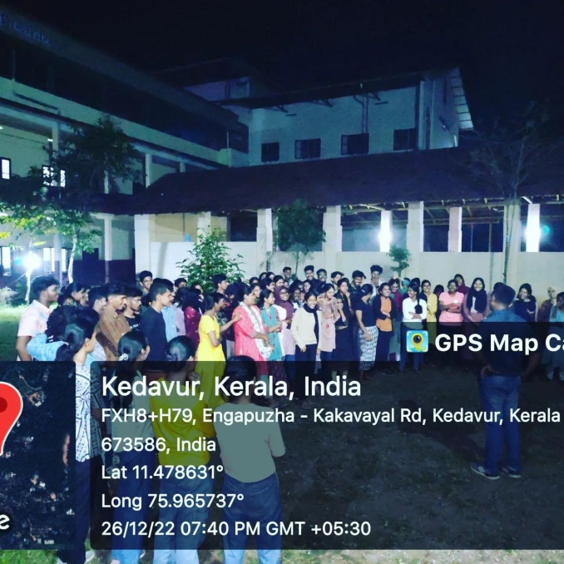

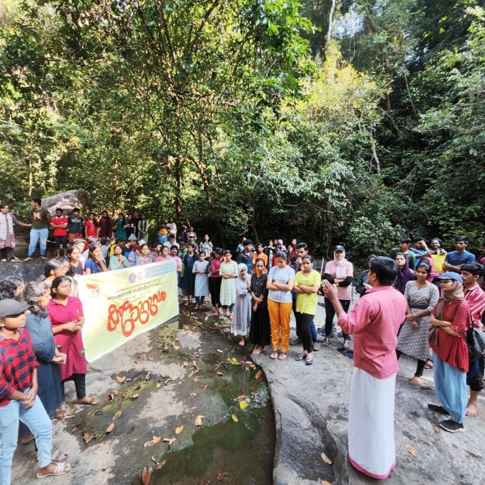

The Valedictory Session was held on 01.01.2023 at 2 pm. The Chief Guest was Clince P.Jose (Wildlife Biologist, Wayanad South Division). Sanath M (II BA Economics), Gayathri Pradyu ( II BA English) , Mayuri (II BA English), and Muhammed Afsal (II BA Economics) were selected as the Best Volunteers owing to their selfless service and enthusiasm throughout the camp days. Valedictory Session was attended by teaching and non- teaching staff of MGM Higher Secondary School Engapuzha, PTA Representative, and people from the locality. Kabeer K.T. (Programme Officer) shared his feedback on the camp. The Vote of Thanks for the Valedictory Session was delivered by Abdul Riyas K. (Programme Officer). The Special Camp was a great success as it could educate the volunteers on time management, group-living and social service. The camp helped volunteers to develop leadership skills and also to rebuild themselves as better human beings who are committed to render selfless service towards social welfare.