GOVERNMENT ARTS AND SCIENCE COLLEGE, MEENCHANDA
Unit No. : 17&107 Annual report2020-21
Details report of regular activities for the period from 1/6/2020 to 31/5/21
Allocation of NSS Volunteers:
- Actual Enrolment: 200 Male : 68 Female : 132 Total : 200
 | OC |  |  | SC |  |  | ST
 | Male | Female | Total | Male | Female | Total | Male | Female | Total
Enrollment | 39 | 113 | 152 | 26 | 18 | 44 | 3 | 1 | 4

- No. of adopted Villages : kappakadvu / panniyangara Distance from the College: 4 KM)
- Details of the achievements on the following areas during the Month :
Sl. No. | Activity/Asset creation |  | Month | No. of NSS Volunteers involved | Remarks
1 | Blood Donation |  | On requirements | 40 | nil
2 | Plantation |  | June | 100 | nil
3 | World Blood Donors day |  | June | 50 | Online
4 | Reading Day |  | June | 75 | Online
5 | Yoga Day |  | June | 55 | From home
6 | Financial Support for poor children |  | June | 100 | Online collection
7 | International Day against Drug Abuse |  | July |  | Online
8 | Independence Day Celebration |  | August | All students | Online
9 | Rashad MemorialMagazine award |  | August
10 | Teachers’ day |  | September |  | Online
11 |  | World Suicide Prevention Day | September |  | Online
12 |  | Ozone day | September | 67 | Online
13 |  | NSS Day | September | All volunteers | Online
14 |  | Online Training Programme | September | 95 | Online
 |  | Gandhi Jayanti | October | 90 | Online
15 |  | Covid 19 Pledge | October | 200 | Online
16 |  | Kerala Piravi Day | November | 100 | Online
17 |  | Cleaning NSS office | November | 25 | Offline
18 |  | Lockdown competition |  | 175 | Online
19 |  | Plastic free campus | December | 100 | Offline
20 |  | International day of persons with disabilities | December |  | Online
21 |  | International Volunteer Day | December |  | Online
22 |  | World human rights day | December |  | Online
23 |  | Snehanidhi Fund collection | December | 100 | Online collection
24 |  | NSS Selection 2020-21 batch | December |  | Offline
25 |  | College getting ready to open | January | 75 | Offline
26 |  | Orientation program for new batch | January | 100 | Online
27 |  | Public awareness program for water conservation | January | 100 | Offline
28 |  | Bed sheet for poor patients | February | 100 | Offline
29 |  | Water for birds | March | 55 | Work from home
30 |  | Community outreach program | March | 33 | Offline
31 |  | Women’s day celebration | March |  | Online
32 |  | Fund collection for House Project of NSS Kozhikode district cell | March | 45 | Offline
33 |  | Blood donation awareness program | April | 100 | Online
34 |  | Covid 19Vaccine Registration Help desk and Awarness program | April |  | Online
35 |  | Vishu and Ambedkar Jayandhi Celebration | April |  | Online
36 |  | FUND RAISING FOR OUR FIENDS FATHER, Kaithang | May | 150 | Online collection

Detail reports of regular activities 2020-21

Environment Day

NSS units, 17 and 107, observed Environment Day on June 5th 2020.Volunteers and Programme Officers planted saplings in their own homes and shared the pictures in the WhatsApp group. Then the images were collated and made into posters and circulated on social media.

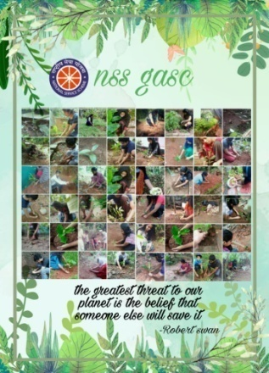

World Blood Donors day

World Blood Donor day is observed by the Volunteers on June 14, 2020. Digital Posters were made by the volunteers on the topic, “Every drop of blood is a gift of life” and circulated it on various social media to make awareness regarding blood donation among students and public.

Reading Day

On June 19th2020, units celebrated Reading Day with the theme of “Read and read on to be a good human being” by making various posters on the same theme to spread on Instagram.

Yoga Day

International Yoga Day is observed on June 21st 2020 with the theme of “Yoga at home and yoga with family”. Various ‘asanas’ were demonstrated by a student on a video and released it on Instagram on the same day.

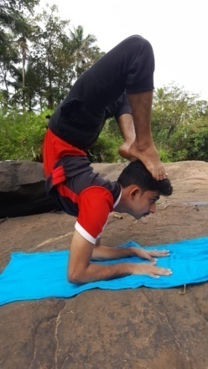 | 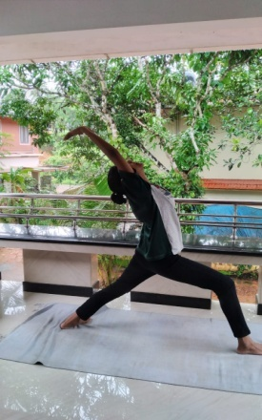
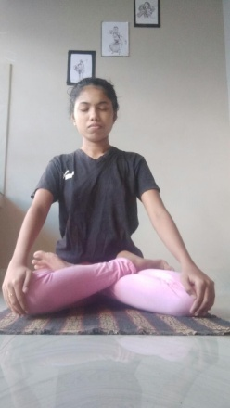 | 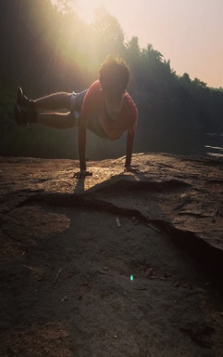

Financial Support for poor children

On June 23rd 2020, there was a fund raising programme in association with ‘Solace Youth Kozhikode’- an organisation which stands to support and to take care ofchildren with long term illness. This financial support is given to provide them school kits. Contributions of students and teachers were collected through Google pay.

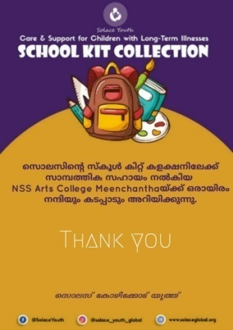

International Day against Drug Abuse
International Day against Drug Abuse and Illicit Trafficking was observed by NSS units on June 26th 2020 with digital poster designing competition on the topic “Better knowledge for better care” and “say no to drugs”. The winner was Afrah Mohammed Raoof, II B.Sc. Physics.

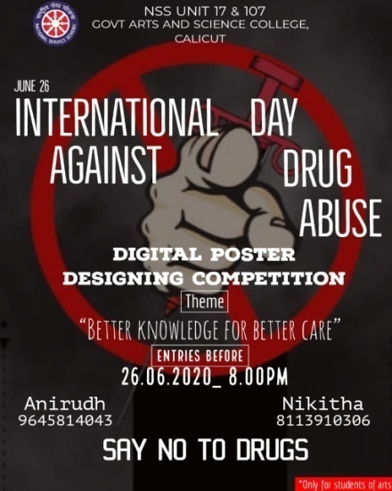 | 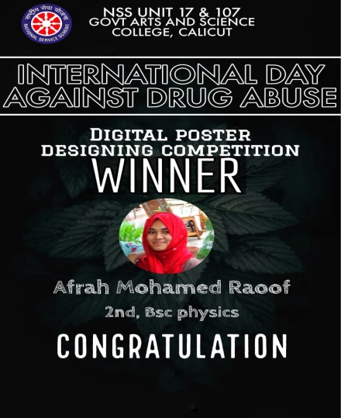

- Independence Day Celebration
Even during this pandemic time, the units were able to celebrate Independence Day extensively through Google Meet.Principal, Ms.ShajiEdakkotte inaugurated the programme and also delivered a key note address.And a quiz programme (GouthamK Pradeep, 2ndB.Sc. Mathematics was the winner) and an essay writing competition (Reshma Krishnan, 2nd B.Sc. Mathematics) were also conducted for students. And a video of NSS activities during the lockdown was also released on this occasion.

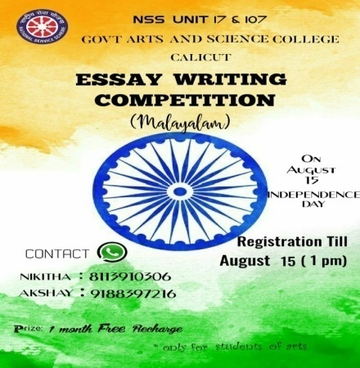 | 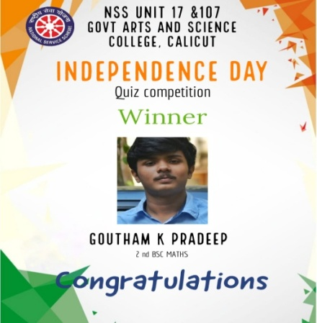 | 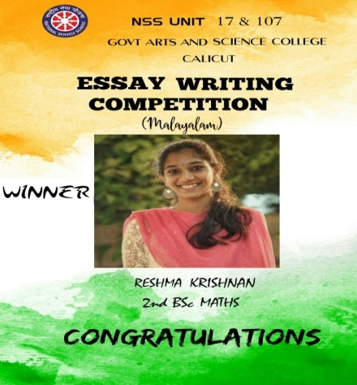

- Rashad MemorialMagazine award
NSS units wonRashad Memorial NSS Magazine Award for three consecutive years. In this year too, within few days, the volunteers prepared a magazine titled “Eth Vakuppil” of no more than 100 pages.
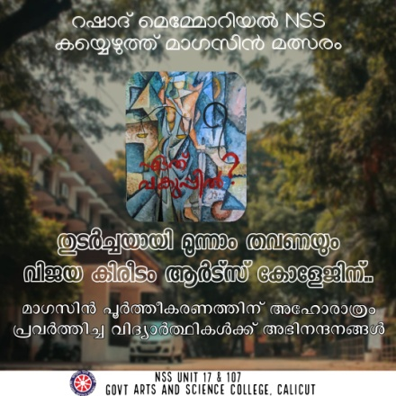

- Teachers’ day
On September 5th2020NSS units observed Teachers’ day appropriately. And made posters for wishing teachers’ day and sent to all teachers.
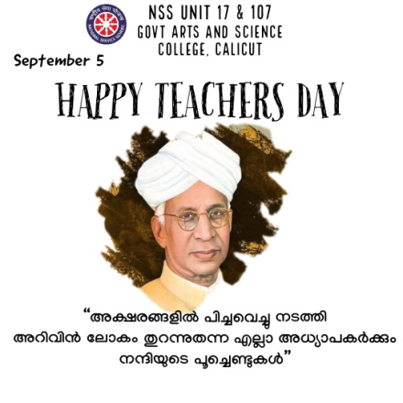

- World Suicide Prevention Day

On September 10th2020, World suicide prevention day was observed with the theme of “Suicide ends your life than your body”. And circulatedon various social media platforms to make awareness among students and public.

- Ozone day
As part of Ozone day observation, an online competition for poster making on “Ozone for life” was held on 16th September 2020. Program officer Dr.MUJEEB RAHMAN shared a vedio talk on the importance of ozone day
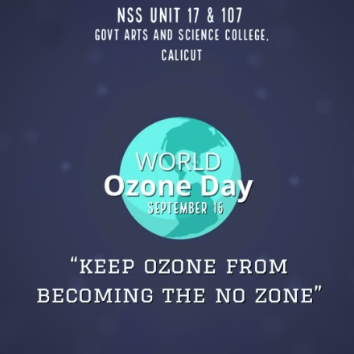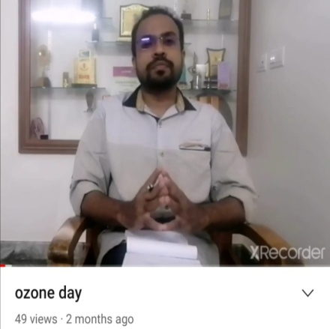

NSS Day

As part of NSS Day celebration, an online three dayfund-raising campaign using “Be with Nest” hashtag was held for NEST Koyilandy (a pain and palliative care centre). Teachers and students contributed money through Google pay.And a hand painting competition was also conducted for the volunteers on the topic “survival”. Neelima A P, 2nd year BSc botany was the winner. “Make service your fist priority” was the general theme of NSS Day celebration.

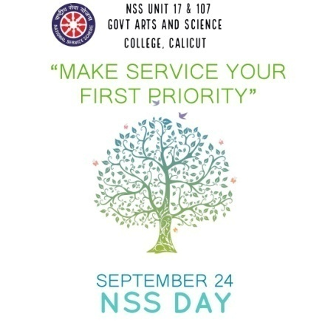 |  | 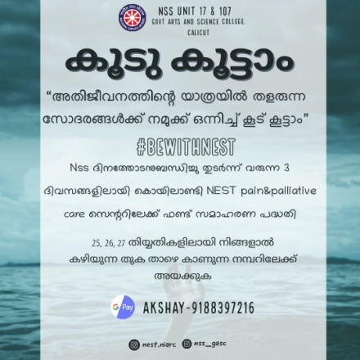
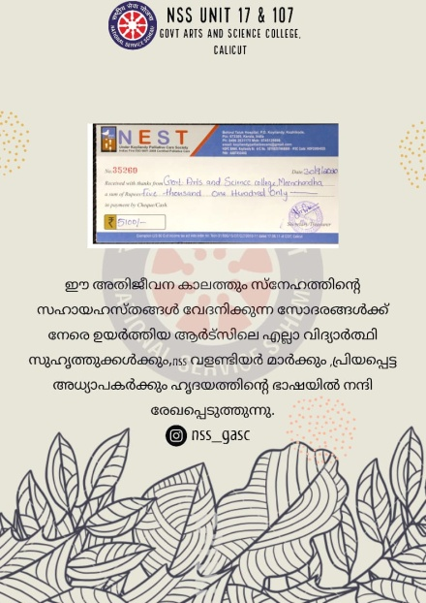 | 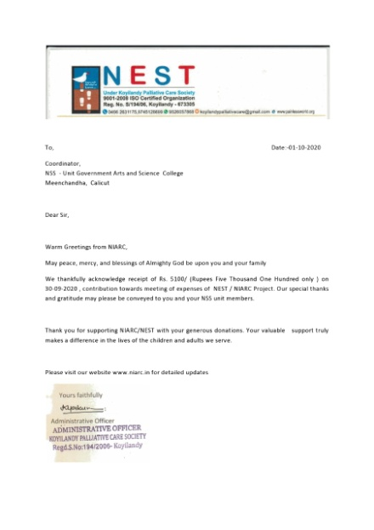

- Online Training Programme
NSS Units held a Training Programme as webinar in association with Field Outreach Bureau,Ministery of I and B, Govt.ofIndia. MV Zachariah, National Recruitment Agency, University of Calicut was the speaker. Dr ShajiEdakkotte,Principal was also present on the occasion.
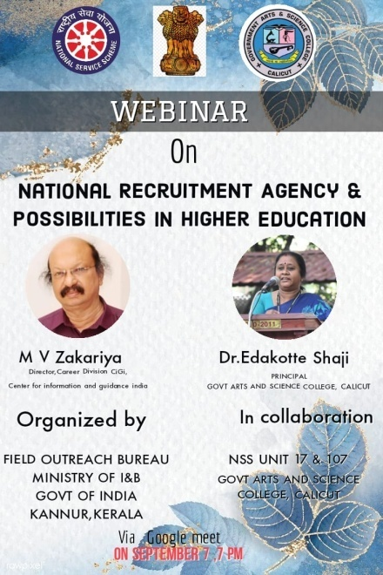

- Gandhi Jayanti

Gandhi Jayanti was celebrated as usual on 2nd October 2020. A“home cleaning challenge” was organised with “everyone must be his own scavenger” as the theme. Volunteers shared the pictures in the WhatsApp group and the images were assembled and made into digital posters. Then a poster making competition on “Shuchithwam” (hygiene)was also held. FirstShelma K (2nd BA Economics), second Afrah Mohammed Raoof, (2nd B.Sc. Physics), third Priya T Prakash (2nd BA Hindi) were the winners.

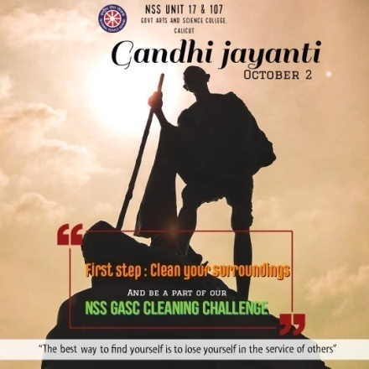 | 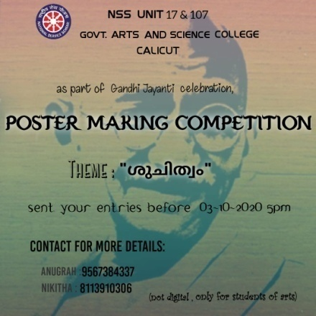
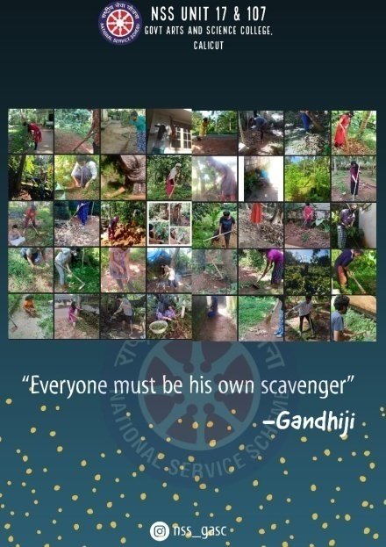 | 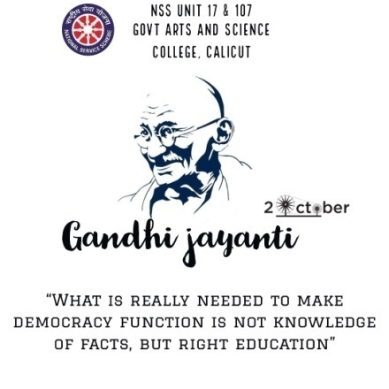

- Covid 19 Pledge
‘Covid 19’Awareness Pledge was taken by the volunteers and teachers on October 8th 2020. And digitalposters were also made on“reduce your risk of Covid 19” and “a promise to self”.
- Kerala Piravi Day
On November 1st2020, units celebrated Kerala PiraviDay. Slogan writing competition and quiz competition were organised for students.
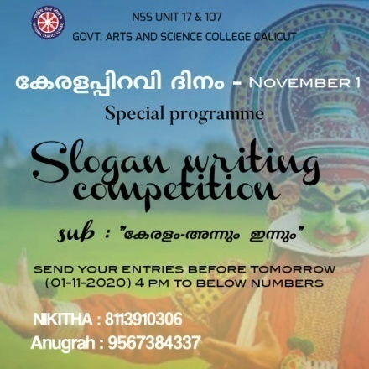 | 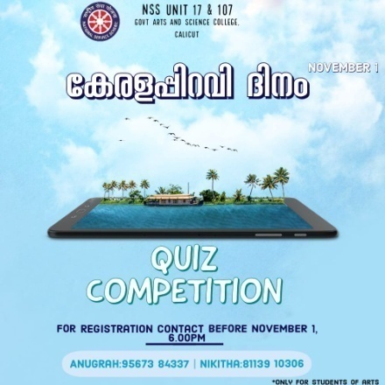
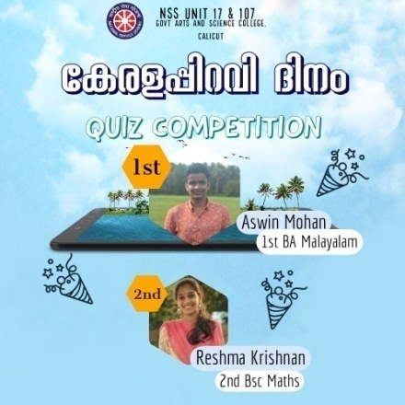 | 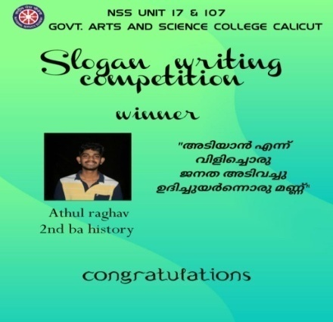

- Cleaning NSS office

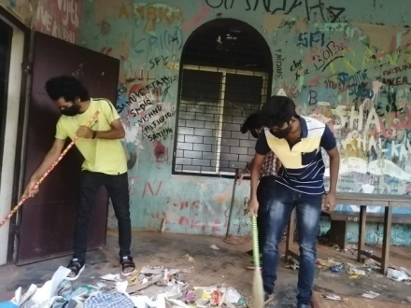 | 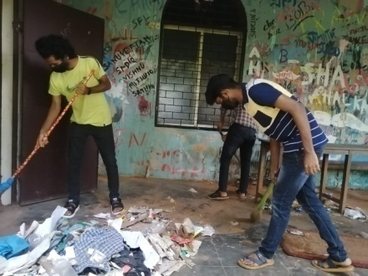

- Lockdown competition
To engage students during lockdown NSS organized different types competition online

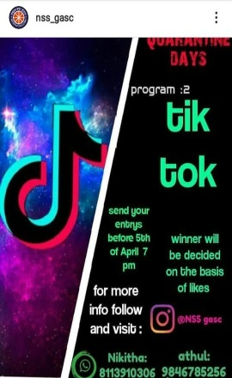 | 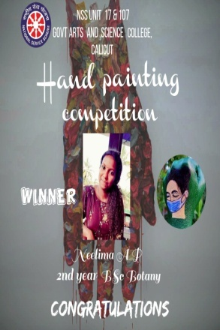 | 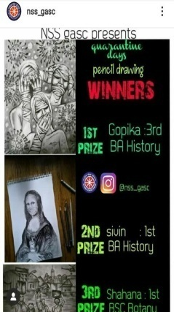 | 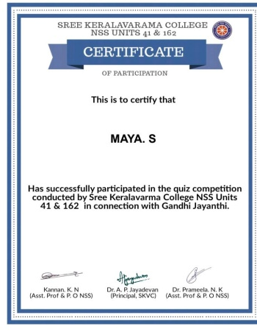
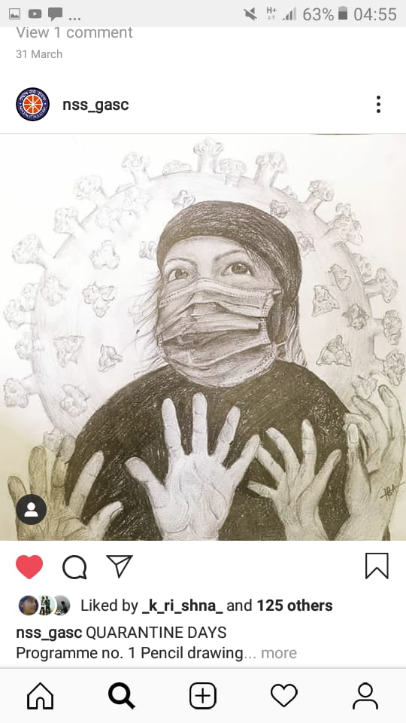 | 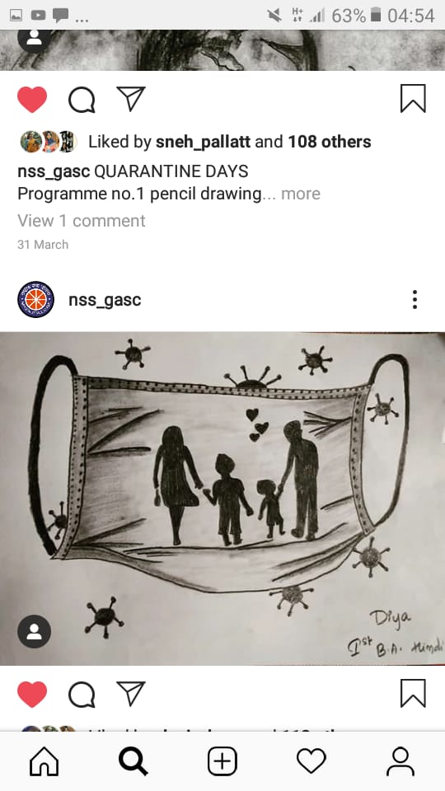 | 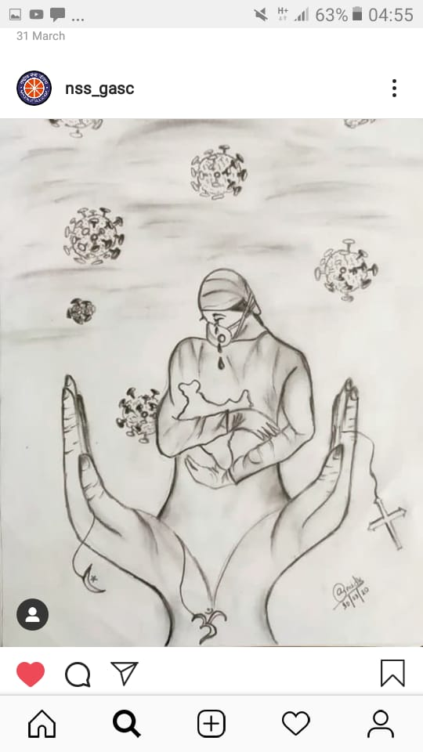 | 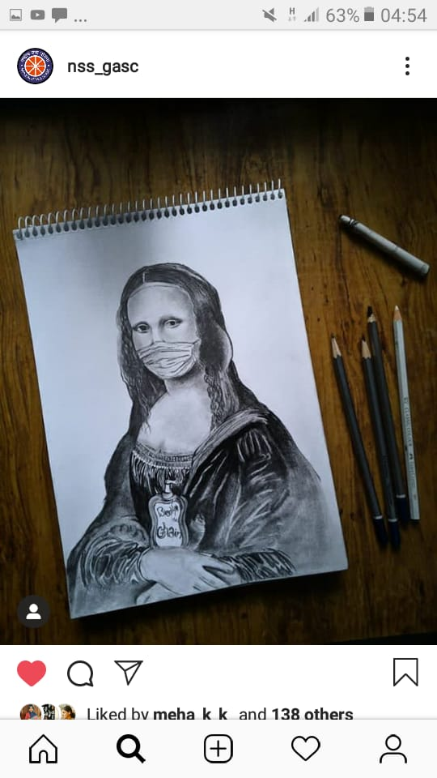
Plastic free campus
As part of Plastic Free Campus Project, NSS units distributed cloth bags made by the volunteers among the teachers and non-teaching staff on November 24th 2020. And it was inaugurated by giving a cloth bag to the principal.

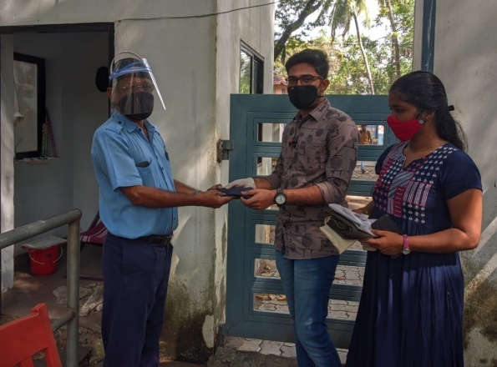 | 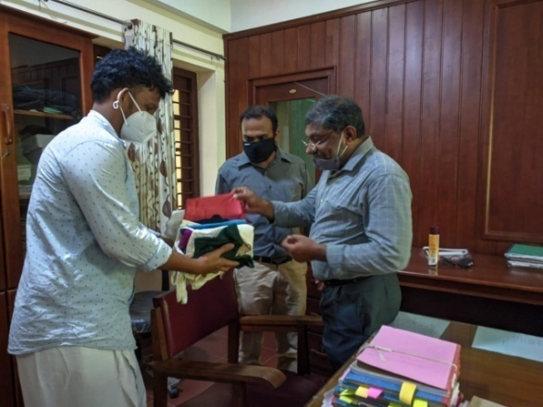
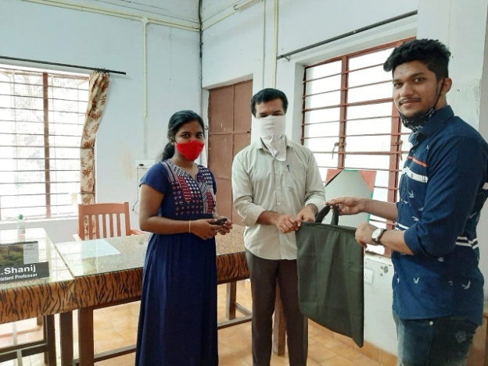 | 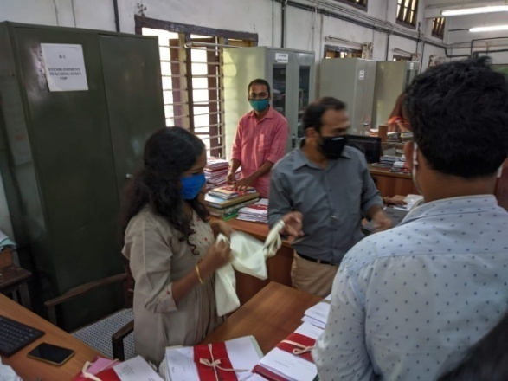

International day of persons with disabilities
It is observed by the Volunteers on December 3rd, 2020. Digital Posters were made by the volunteers on the topic, “you are not disabled by the disabilities you have, you are able by the abilities you have” and circulated it on various social media.
International Volunteer Day
It is observed on December 5th 2020 with the theme of “together we can through volunteering”. Different digital posters made by a student and released it on Instagram on the same day
World human rights day
It was observed by NSS units on December 10th 2020 with digital poster designing competition.
Snehanidhi Fund collection
There was a fund rising on 17th December 2020 to help the family of Naja, a seven year old girl who lost her life in a car accident. Contributions of students and teachers were collected 8351 rupees through Google pay and donated.
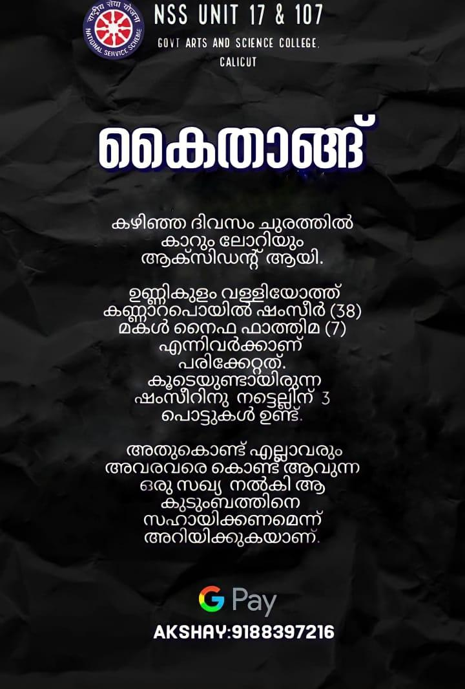 | 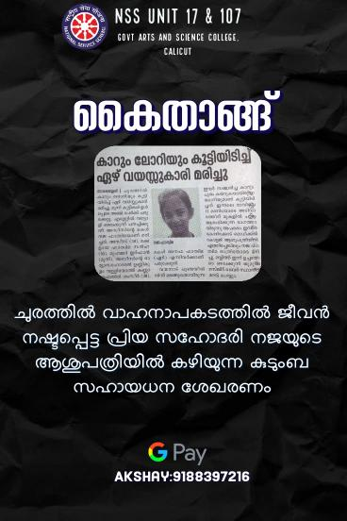

NSS Selection 2020-21
NSS selection process for the academic year 2020-21 was conducted on campus on the following days of November 26, 27,28,29,30 and December 1st. There was an online selection too for the students from afar on 2nd and 3rd December 2020. The selection process was done strictly following the Covid protocol by POs with the help of NSS unit secretaries. As part of this selection process, 6 days of interview session and campus cleaning were conducted. The applicants were asked to submit a list of intended projects (of different and innovative ideas and programmes) they wanted to be conducted/coordinated by the NSS units and the submitted projects are listed out by the unit leaders according to their quality. It was also suggested making a ‘kitchen garden’ at home by the applicants during lockdown. 100 students were selected this year.
College getting ready to open
Before opening the college after lockdown, college NSS units cleaned entire campus to welcome students.
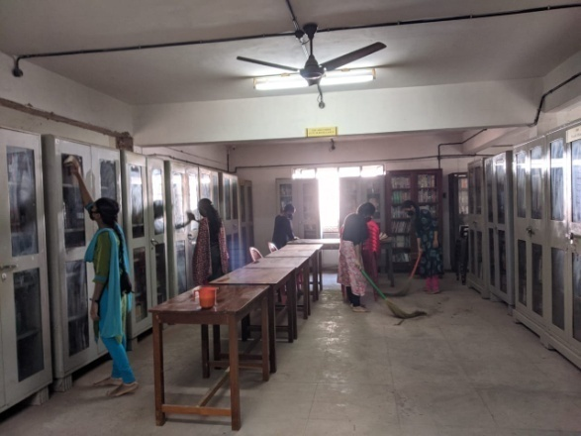 | 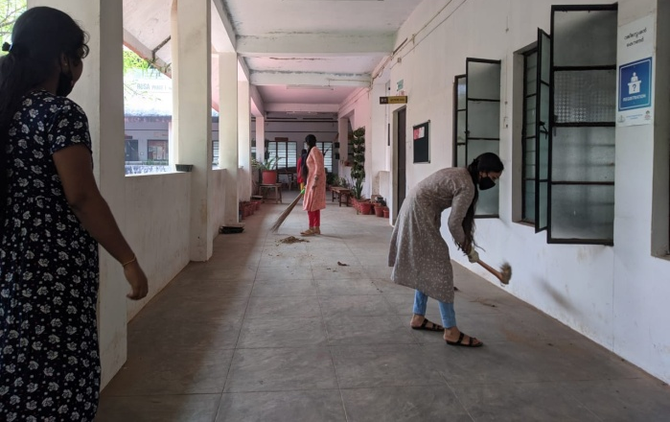
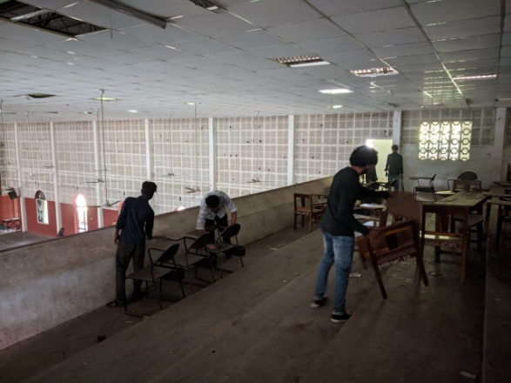 | 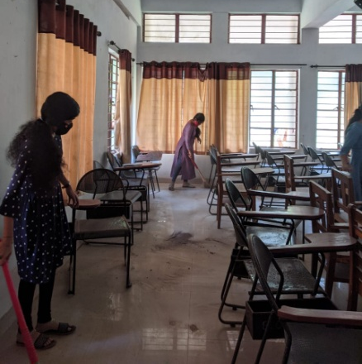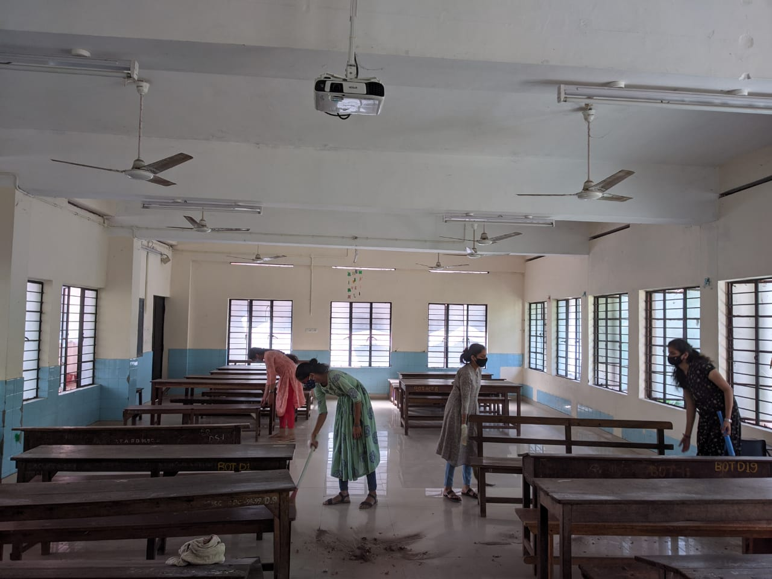
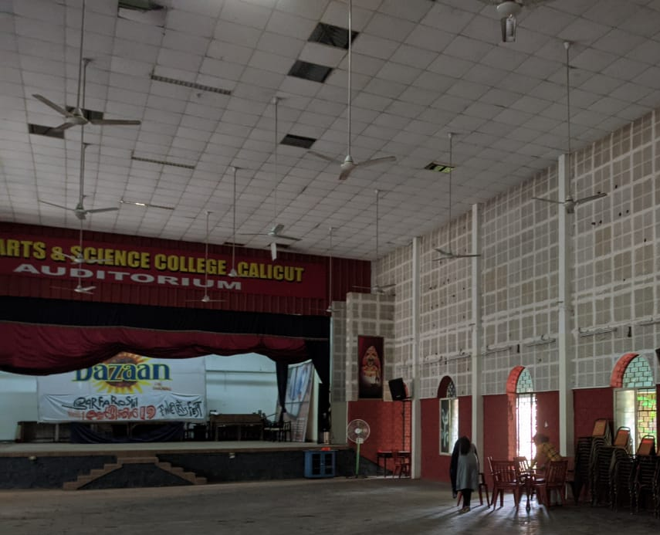 | 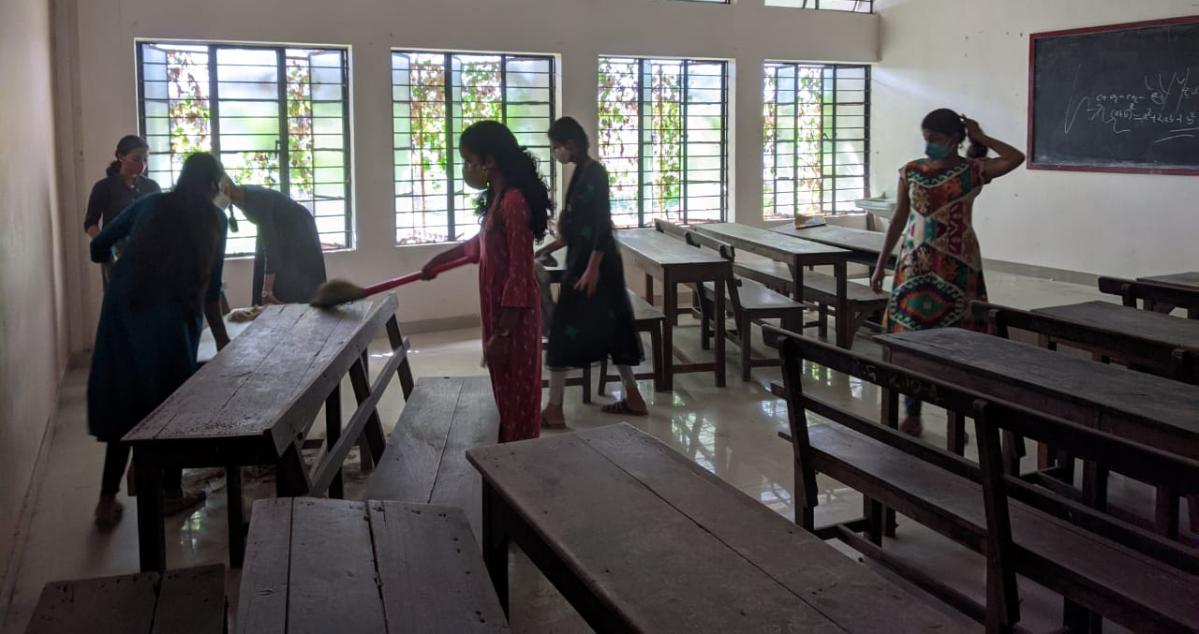

Orientation program
This year orientation program for first year students were carried out on27/12/2020. Dr.Sunny NM, ETI Coordinator, University of Calicut gave training to volunteers. 100 volunteers joined the programme .
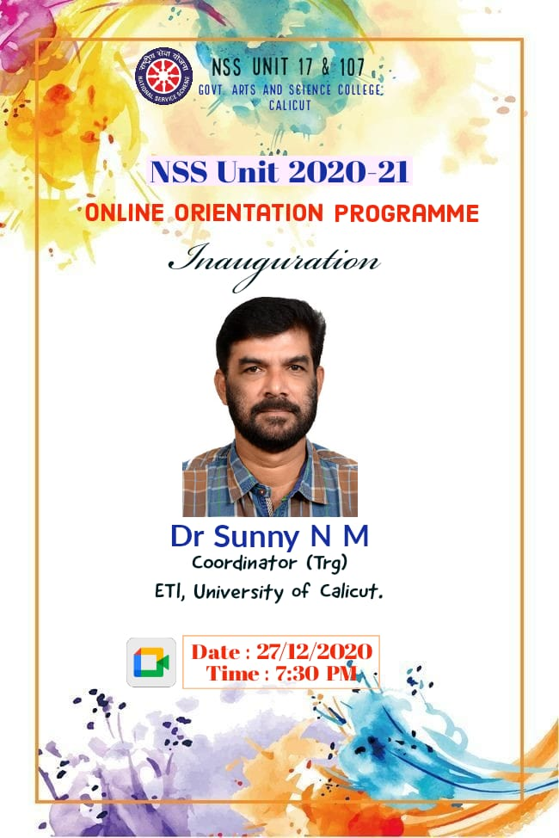
Public awareness program for water conservation
In association with Kozhikode Corporation our NSS team actively involved in awareness program for water conservation and cleaning of Mundakanthode in Beypore. NSS volunteers visited more than 100 houses in the village and explained them about the seriousness of pollution of Mundakan thodu and importance of cooperating cleaning mission. NSS volunteers took the comments of locals and reported to authority. After campaigning mission volunteers involed in cluster formation for cleaning process. NSS unit have been associating with corporation officials since in the beginning of the project.
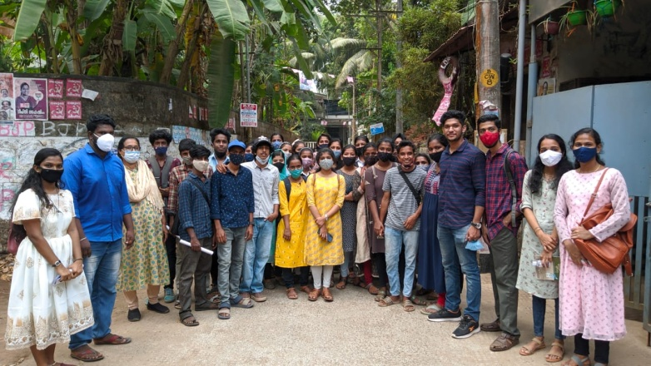 | 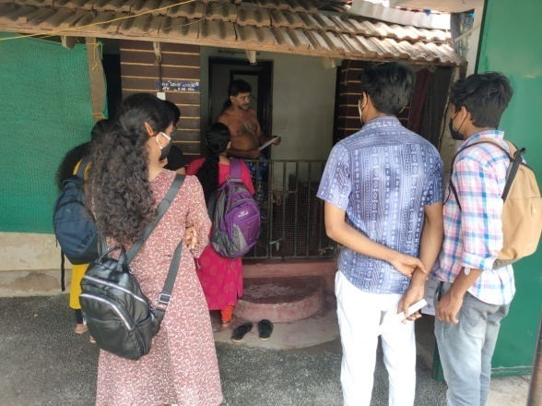
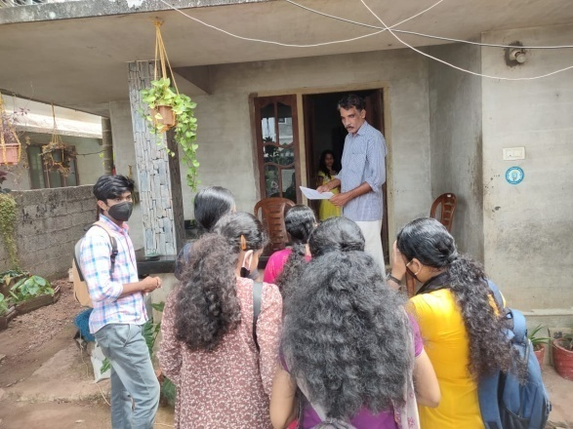 | 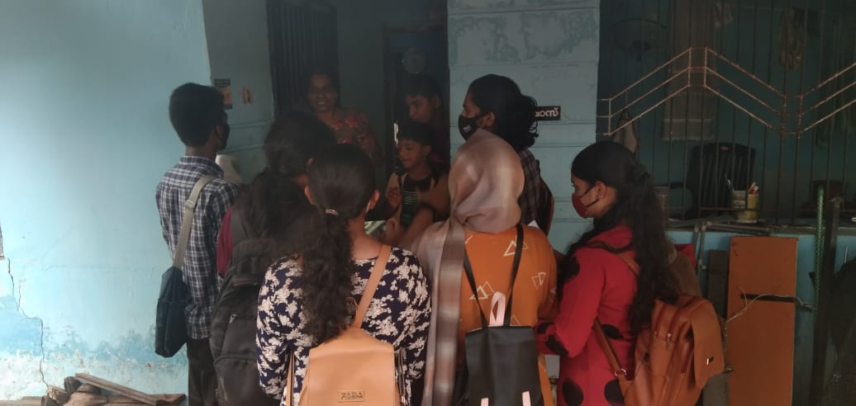

Bed sheet for poor patients
College NSS unit has collected money to fetch bedsheets and blankets for poor patients. Volenteers bought items from wholesale market and packed well. After identifying needy persons bed sheets and blankets were handed over in the presence of principal on 8/3/2021.

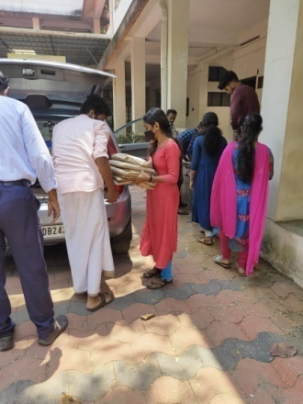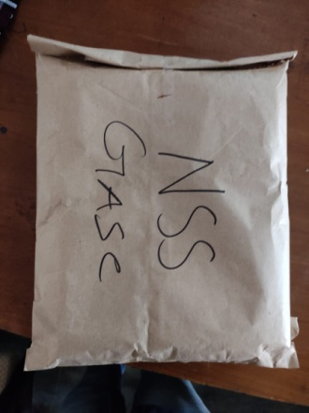 | 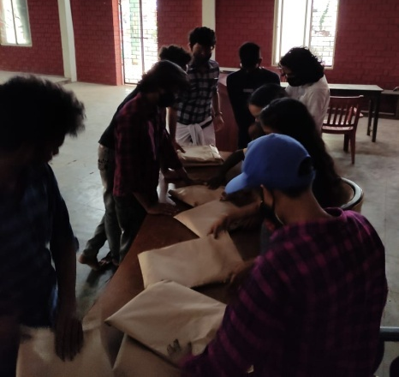
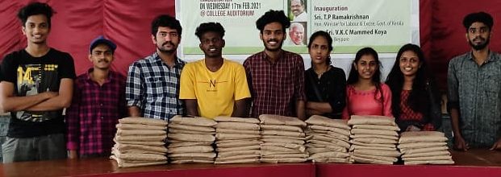 | 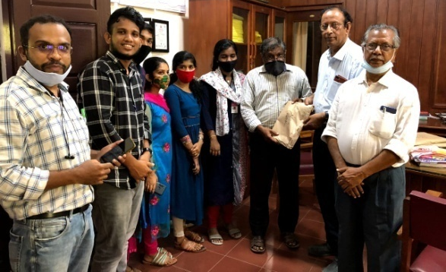

Water for birds
NSS units have organized campaign water for birds. All NSS volunteers set hanging water pots in their locality and photos shared
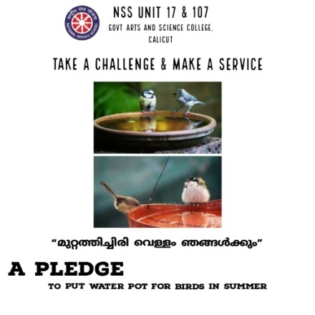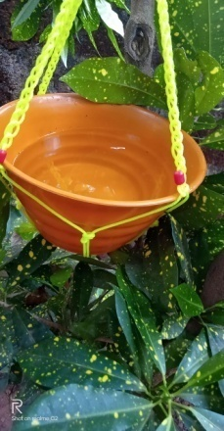 | 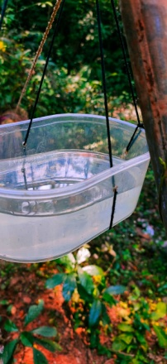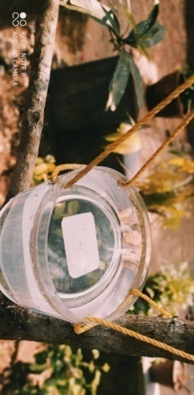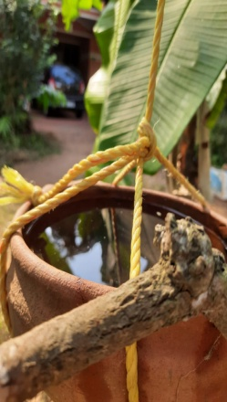

Community outreach program
To cultivate community service attitude, students were directed to organize programs in their locality and spread positive message for kids. Volunteers visited local Angnavadi or clubs and organized different programs. Prices were distributed for winners. Fund for the programs were arranged by NSS units. NSS PO gave all directions to organize such events.
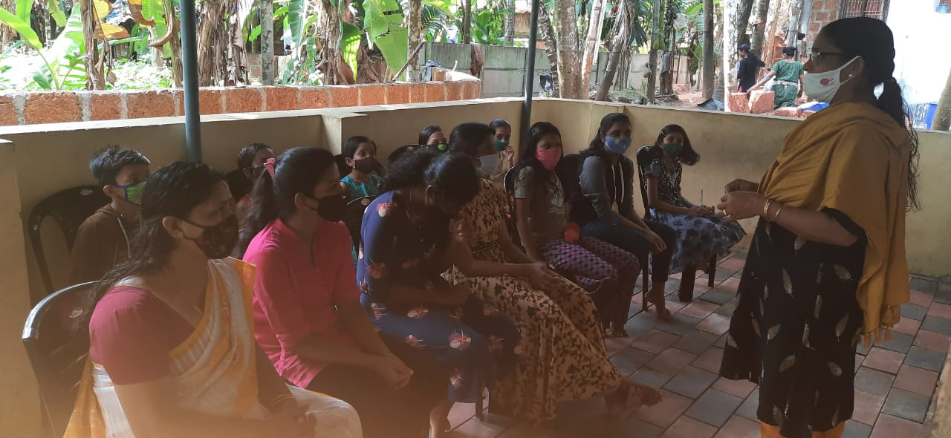 | 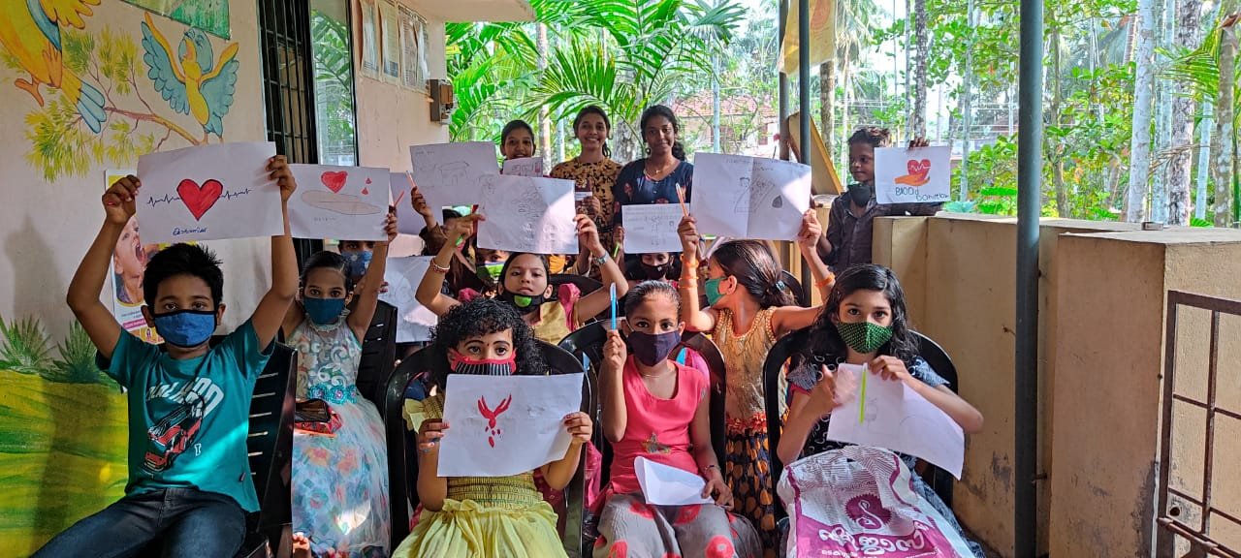
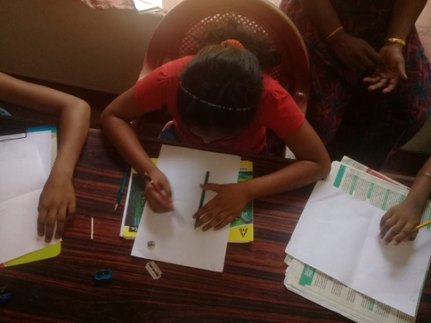 | 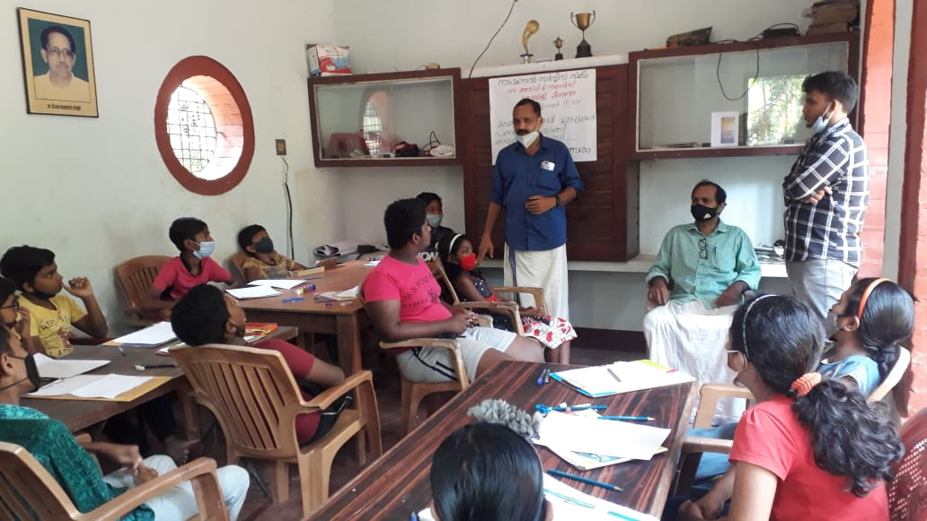

Women’s day celebration
NSS unit has organized various programe in connection with women’s day. Portrait drawing competition was organized at college level, prices were given to the winners
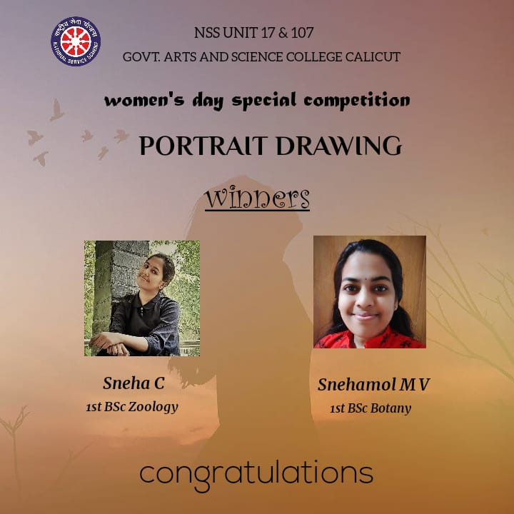
Fund collection for House Project of NSS Kozhikode district cell
College unit NSS Organized major fund collection in Kozhikode town for the house project of district NSS cell. Twenty students participated in the program and collected more than 15000/- rupees.
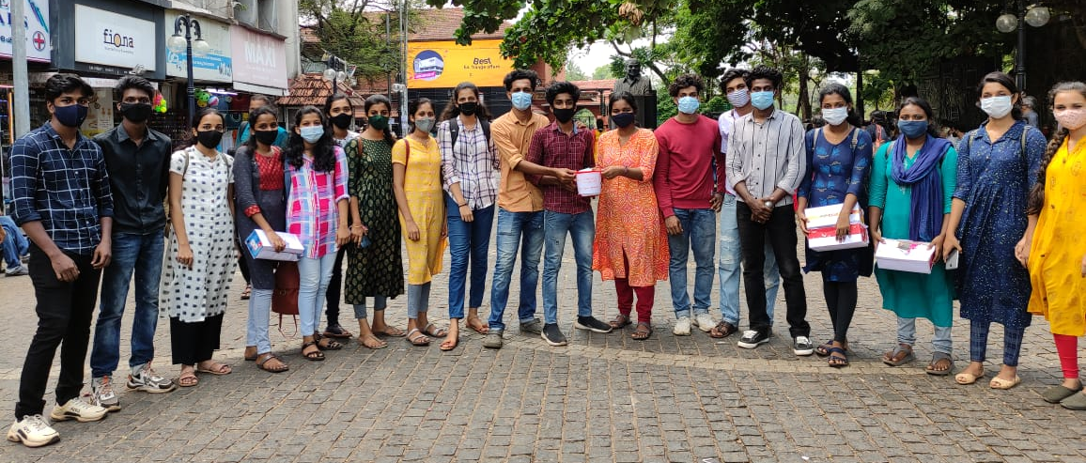
Blood donation awareness program
In the covid pandemic there is acute shortage of blood in blood banks of various hospitals, understanding this suitation NSS unit organized blood donation awareness programme and blood donation camp in association with Kottaparamb Govt Hospital

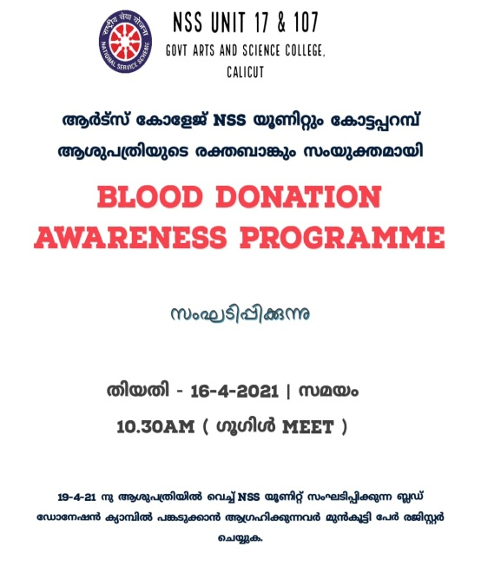

Covid 19Vaccine Registration Help desk and Awarness program
Our NSS unit opened a help desk for public to help them for registering for vaccination. Large numbers of public sought our help for registering vaccination. NSS unit actively participated for vaccine challenge campaign of Govt of Kerala .
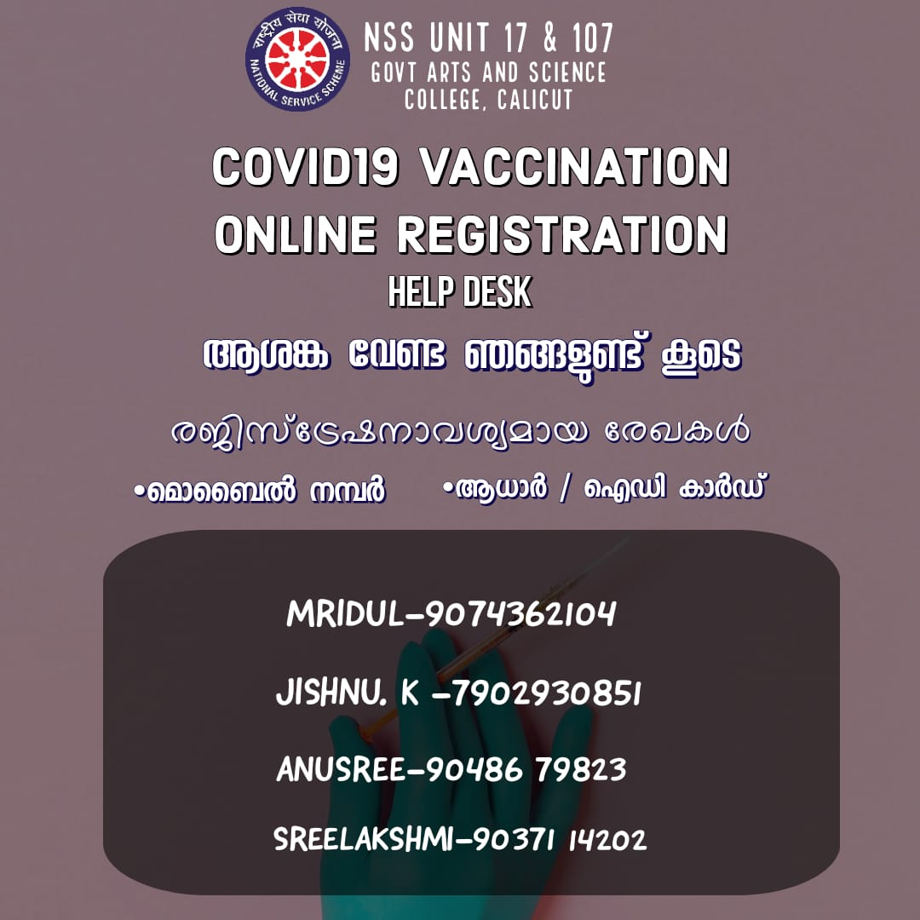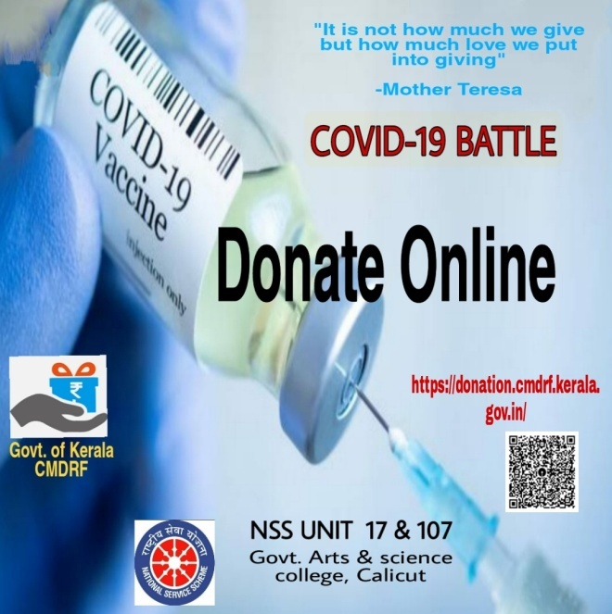

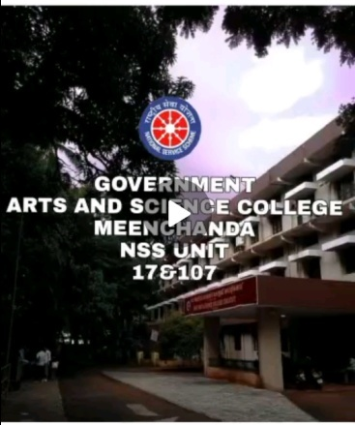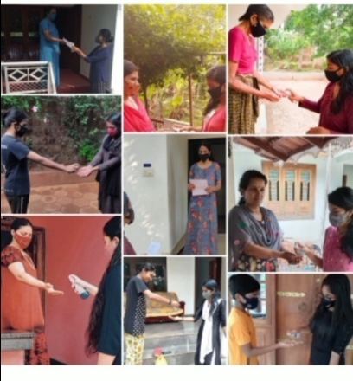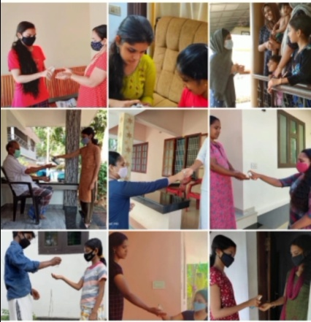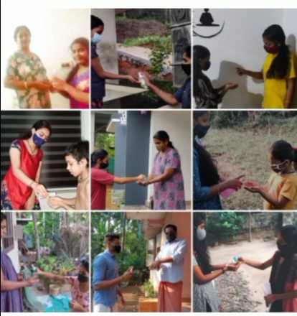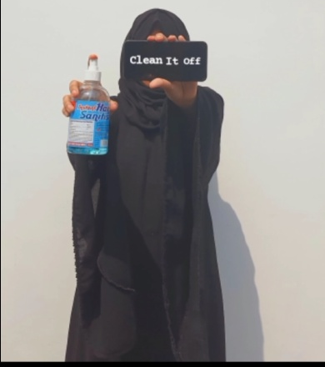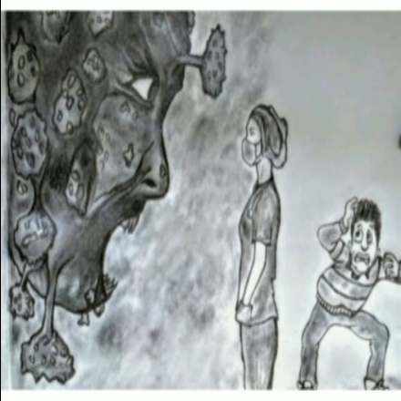

Vishu and Ambedkar Jayandhi Celebration

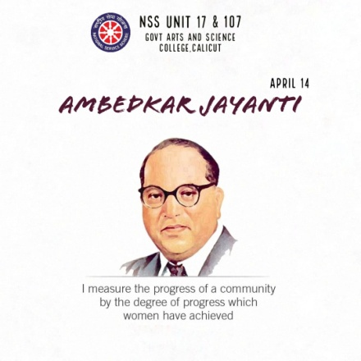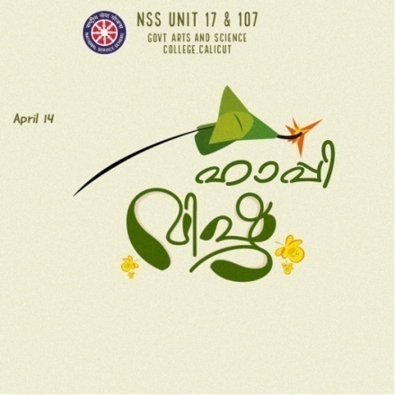
FUND RAISING FOR OUR FIENDS FATHER, Kaithang

When the father our student second year mathematics was seriously illed and admitted in hospital for a critical surgery of cost 8 Lakhs , NSS collected alone 88000/- and with Pain and palliative another 30000/- total sum of 118000/- rupees and handed over
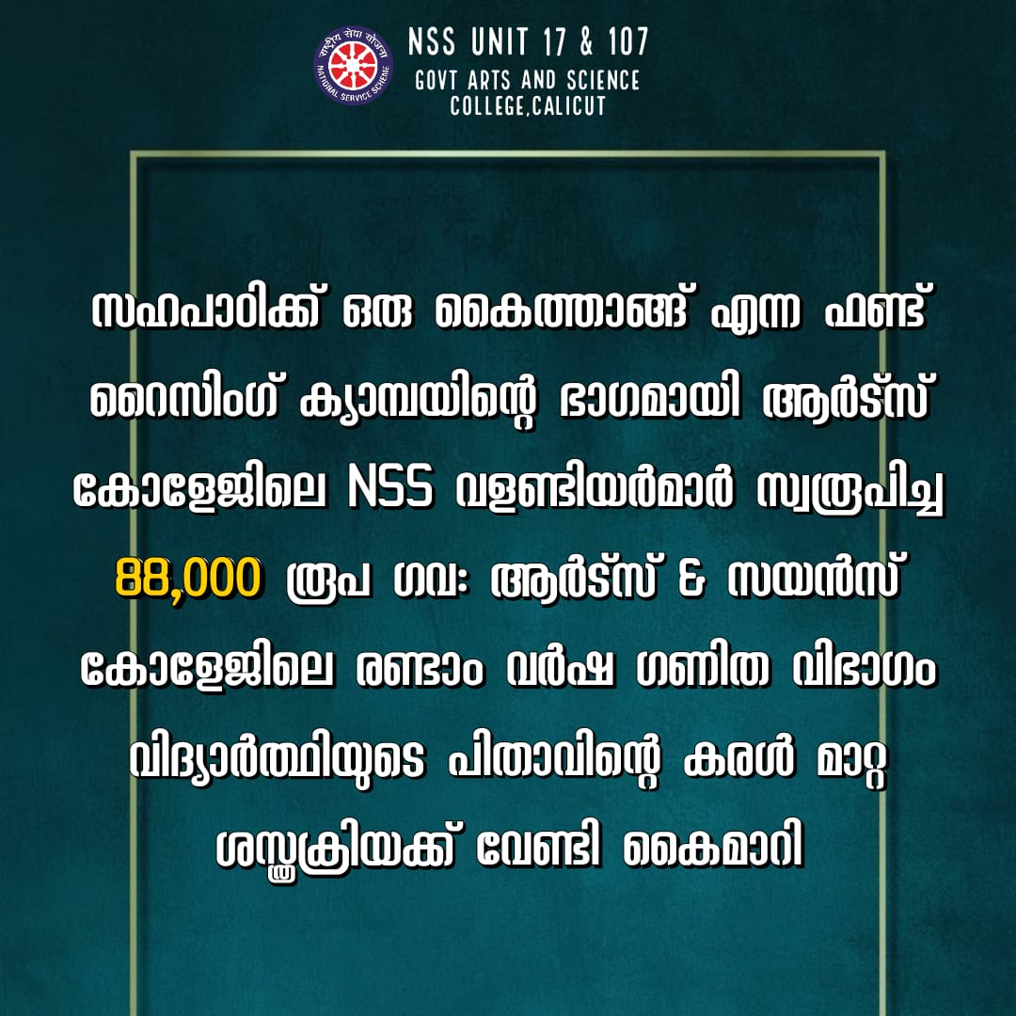

Programe officers
Dr.MUJEEB RAHMAN P (UNIT 17)
SUREGA (UNIT107)
31/5/21
Meenchanda

