**DEPARTMENT OF MANAGEMENT STUDIES**

**EVALUATION REPORT 2021-2022**

The department established as an independent department since 2017, although BBA course started in 2013.Untill 2017, the department was under the shadow of the commerce department.

The department is committed in preparing the students to face tomorrow’s uncertainty with confidence and to serve business and society in enchanting way.

The academic year 2021-2022 began in offline mode as per the circular from the Kannur University, when the covid pandemic was under the control. However in certain circumstances, the department engaged classes both in offline and online mode simultaneously.

The department succeeded in completing the syllabus within the stipulated time. One of the faculties Ms Haritha Rajeevan resigned on 30/11/18 and Ms Mahitha T V replaced the post on 06/12/21. The college admitted 53 students in BBA course in 2021 – 2022 and the department witnessed the passing out of the fifth batch of BBA since the inception of the department.

**FACULTIES**

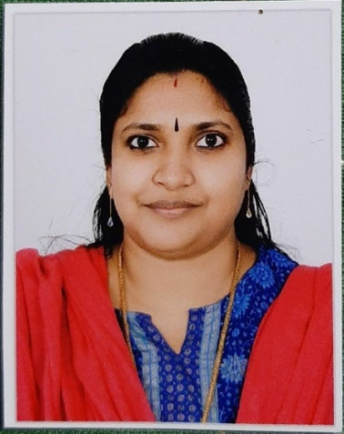 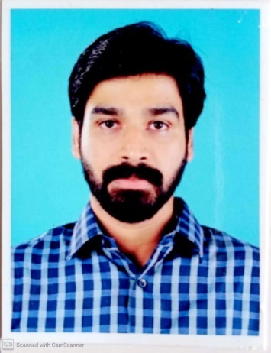

**M GREESHMA PAVITHRAN – HOD SANGEETH K**

**(M.Com, MBA, M Ed) (MBA)**

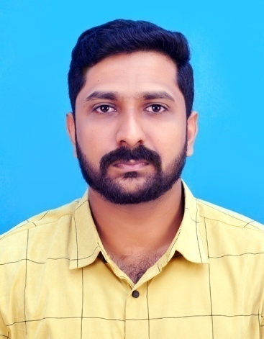 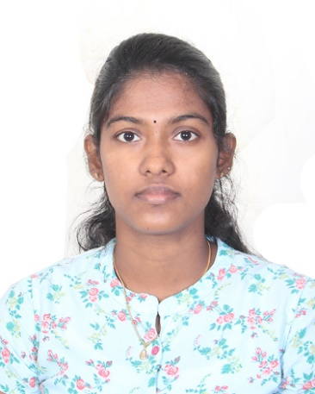

**VINIL P VISWANATH MAHITHA T V**

**(MBA) (MBA)**

1. **CURRICULAR ASPECTS**

***1.1 CURRICULUM ENRICHMENT***

**Session On:**

* **“ SWOT ANALYSIS”** – I BBA 2021-2024 Batch : **Sangeeth K** ( Dept Faculty) 17/10/21
* **“ENTREPRENEURSHIP AWARENESS PROGRAM “** –organized by department of Management Studies in collaboration with **DIC,Kannur** on 26/10/21

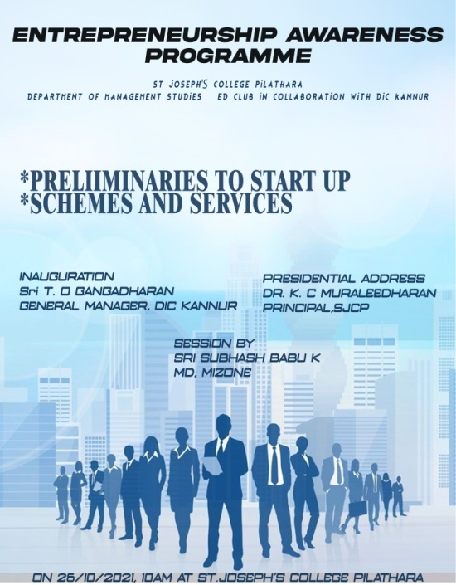

* **“DEBATE: ONLINE TEACHING LEARNING SYSTEM”**  - II BBA 2020-2023 Batch : **M Greeshma Pavithran**( Dept Faculty) 29/10/21
* **“BUSINESS QUIZ ”** – I BBA 2021-2024 Batch : **Sangeeth K** (Dept Faculty) 22/11/21
* **“ DEBATE: “KNOWLEDGE Vs CREATIVITY”** – III BBA 2019-2022 Batch : **Vinil P Viswanath** (Dept Faculty) – 22/12/2021
* “**PADAVU**” workshop on 12-11-22 for 2020-23 batch

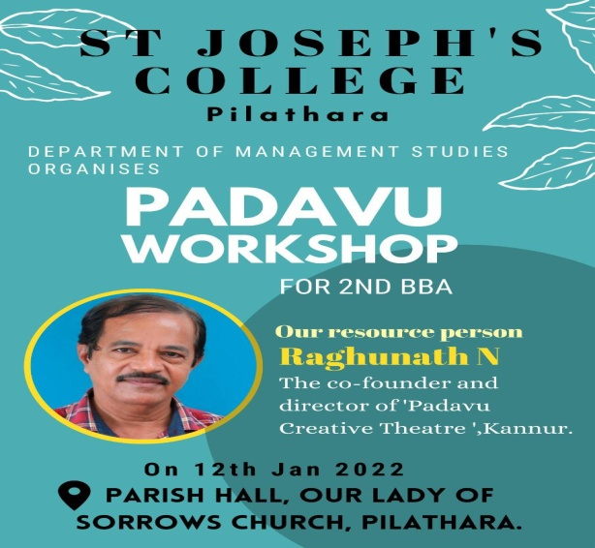

* Department conducted **Study Tour** for the final year BBA(2019-22 Batch) to Munnar & Vagamonn from 13/01/22 to 16 /01/22
* **“SPROUT SESSION”** – II BBA 2020-2023 Batch : **Mahitha T V** ( Dept Faculty) 20/01/22
* Conducted one day industrial visit to **Malabar Innovations** Kannur on 23/01/22 for I year BBA(2021-24 Batch)

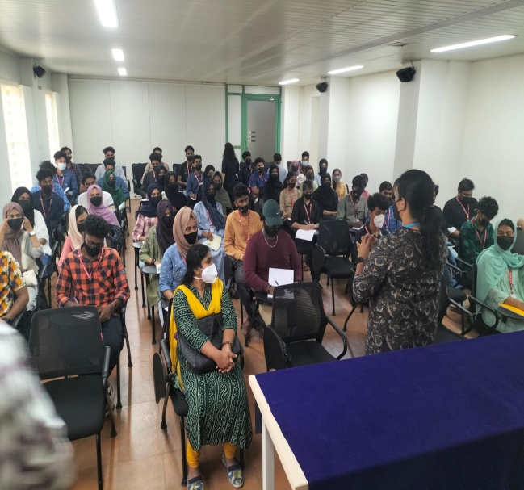

1. **TEACHING – LEARNING & EVALUATION**
   1. ***STUDENT ENROLMENT PROFILE***

|  |  |  |  |  |
| --- | --- | --- | --- | --- |
| **CATEGORY** | **I BBA** | **II BBA** | **III BBA** | **TOTAL** |
| MALE | 28 | 22 | 28 | 78 |
| FEMALE | 24 | 20 | 15 | 59 |
| RURAL AREA | 52 | 39 | 29 | 120 |
| URBAN AREA | NIL | 3 | 14 | 17 |
| APL | 47 | 33 | 39 | 119 |
| BPL | 5 | 9 | 4 | 18 |

* 1. ***CATERING TO STUDENT DIVERSITY***

|  |  |  |  |  |  |
| --- | --- | --- | --- | --- | --- |
|  | | **I BBA** | **II BBA** | **III BBA** | **Total** |
| RELIGION | Hindu | 12 | 12 | 09 | 33 |
| Muslim | 38 | 26 | 28 | 92 |
| Christian | 02 | 04 | 06 | 12 |
| CATEGORY | SC/ST | Nil | Nil | Nil | Nil |
| OBC | 50 | 26 | 42 | 118 |
| General | 02 | 14 | 01 | 17 |

1. ***PART TIME JOB***

* **Arya M II BBA worked with “Maggnessa : Health care &Cosmetics products”– from 10/11/21**
* **Muhammed Ajmal , II BBA worked with “Tyre world”, Pilathara from 01/11/20 to 28/07/21**
* **Online Trading by Abdul Musawir III BBA& Alan Immanuel , II BBA**
* **Anto James of II BBA is engaged with the sale of Artwork – Pencil drawing &wall painting**
* **Fathima Ashraf II BBA started a business named “HOOPYARN” for the sales of Gift Hampers and embroidery Hoop**

***2.3 TEACHING LEARNING***

* **College level and Department level Orientation** 1st Semester BBA students and parents on 18/11/2021. **Rajeev** , Parent of Adithya Rajeev and **Sumayya Basheer**, parent of Fidha Basheer were selected as PTA representative

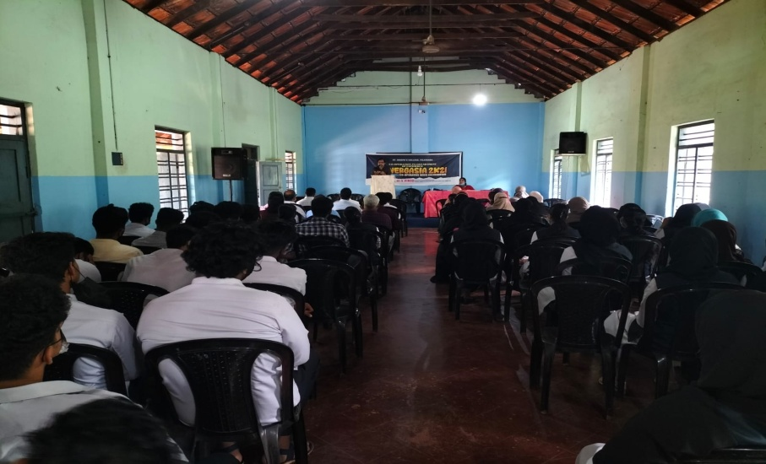

* Separate Google Classrooms for each paper for uploading study materials.
* **“A SESSION ON ONLINE TRADING”** for III BBA 2019-2022 Batch *:* ***ABDUL MUSAWIR* ( III BBA STUDENT)** 30/11/21

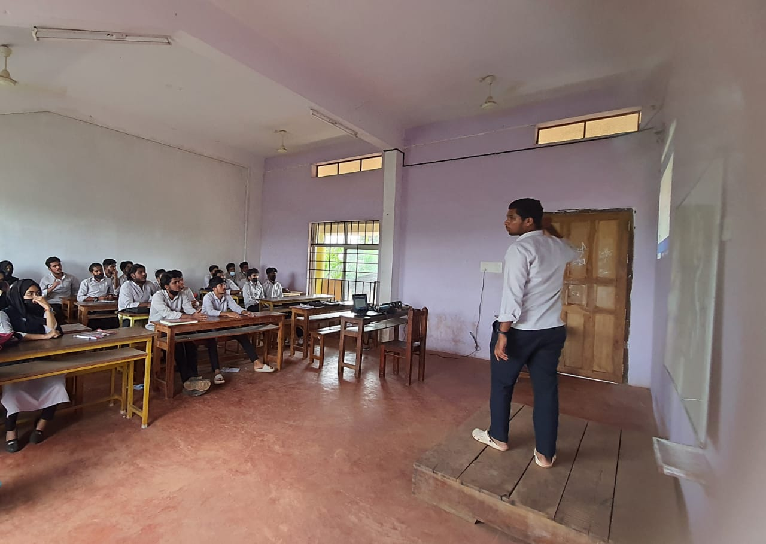

* **FRESHER’S DAY** Celebrated on 10/12/21

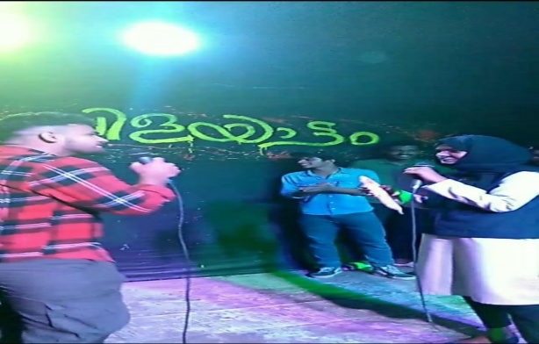

* **“PROJECT ORIENTATION”** III BBA 2019-2022Batch : Vinil Vishwanath ( Dept Faculty) 17/12/21
* **“PRESENTATION SKILL ENHANCEMENT PROGRAMME ; FOR COUNSELLING”** – III BBA 2019-2022 Batch : Vinil Vishwanath ( Dept Faculty) 31/01/22
* The department have bagged first prize in the Food Fest organised by the Union of St Josephs college , Pilathara
* **FAREWELL** for 2019-22 Batch on 23/05/22
* **DEPARTMENT MEETING**

|  |  |  |
| --- | --- | --- |
| **S No:** | **Date** | **Platform/ Mode** |
| 1 | 26/06/21 | Zoom |
| 2 | 26/07/21 | Google Meet |
| 3 | 09/08/21 | Zoom |
| 4 | 02/10/21 | Google Meet |
| 5 | 16/11/21 | Offline |
| 6 | 16/12/21 | Offline |
| 7 | 31/01/22 | Offline |
| 8 | 08/04/22 | Offline |
| 9 | 27/04/22 | Offline |

***2.4 TEACHER PROFILE AND QUALITY AS RESOURCE PERSON***

* **M Greeshma Pavithran**
  + qualified short term course - **“STUDENT** **PSYCHOLOGY”** through SWAYAM platform
  + Attended workshop in connection with the implementation of the Question Bank and Automated Generation & Online transmission of question paper on **07/05/22** in the Cherussery Auditorium , Thavakkara Campus
* **Mahitha TV** joined M.Com - **IGNOU**

***EXTERNAL PROJECT VIVA VOCE: EXAMINATION DUTY***

|  |  |  |
| --- | --- | --- |
| **Date** | **Faculty** | **College** |
| 18th and 19th May 2022 | M Greeshma Pavithran | Sir Syed Institute, Taliparamba |
| Sangeeth K | NEST College, Karivellur |
| Vinil P Viswanath | Payyannur College |

***KANNUR UNIVERSITY EXAMINATION VALUATION DUTY***

|  |  |  |  |
| --- | --- | --- | --- |
| **Sl No:** | **Date** | **Faculty** | **Camp** |
| 1 | 16/06/21 to 21/06/21 | M Greeshma Pavithran | St Joseph’s College, Pilathara |
| Sangeeth k | ,, |
| Haritha Rajeevan | ,, |
| Vinil P Viswanath | ,, |
| 2 | 20/07/21 to 23/07/21 | M Greeshma Pavithran | ,, |
| Sangeeth k | ,, |
|  |  | Haritha Rajeevan | ,, |
| Vinil P Viswanath | ,, |
| 3. | 23/11/21 to 26/11/21 | M Greeshma Pavithran | ,, |
| Sangeeth k | ,, |
| Vinil P Viswanath | ,, |
| 4. | 01/04/22 to 05/04/22 | M Greeshma Pavithran | ,, |
| Sangeeth k | ,, |
| Vinil P Viswanath | ,, |
| Mahitha T V | ,, |
| 5. | 30/05/22 to 06/06/22 | M Greeshma Pavithran | ,, |
| Sangeeth k | ,, |
| Vinil P Viswanath | ,, |
| Mahitha T V | ,, |

***2.5 STUDENTS PERFORMANCE AND LEARNING OUTCOMES***

In the academic year 2021-2022, 24 students graduated out of the 43attendees. There was hike in the pass percentage from 41.60% to **55.81%**. Out of the 24students passed, 18 students scored 60% and above. **Navaneeth Jay** (82.49) and **Anulaya C** (80.54) of 2019 – 2022 batches occupied the first and second position respectively.

First and second semester result of 2020- 2024 batch were also published. The first semester pass percentage was **76.19%** and second semester **41.46%**.

The academic year 2021-2022, the department offered **2 open courses** -

1. **D**isaster **M**anagement
2. **E**- **C**ommerce

**36** students enrolled in Disaster management- (BCom Co-op: 20, BCom CA: 09, BA Eng: 07), out of which 32 students passed – **88.88%** i.e. (BCom Co-op: 17, BCom CA: 08, BA Eng: 07). Four students - **A**shitha P Kumar, **F**athimabi M, **J**inu Mary T, and **N**ihala Ettol have secured **100%** in Disaster Management.

In E Commerce, 07 students enrolled – (BCom Co-op: 05, BA Eng: 02). All the seven students have cleared the paper and the topper was **K**avya **B**alakrishnan – 80%.

1. **STUDENT SUPPORT AND LEARNING PROGRESSION**
   1. ***STUDENT SUPPORT***
2. ***POST ENTRY TEST***

|  |  |
| --- | --- |
| Batch | Date |
| 2020-2023 | 24/07/2021 |
| 2021-2024 | 07/10/22 |

1. ***BRIDGE COURSE***

The department conducted bridge courses –

1. **M Greeshma Pavithran (27/07/21 to 10/09/21 )**

* Basic Accounting ( III Semester : 2020-2023 batch)

1. **Sangeeth. K (08/10/21 to 18/10/21 )**

* Principles & Practices of Management (I Semester: 2021-2024 batch)

1. **Haritha Rajeevan (08/10/21 to 18/10/21 )**

* Managerial Economics ( I Semester : 2021-2024batch)

1. **Vinil P Viswanath (08/10/21 to 18/10/21 )**

* Statistics and Numerical Skills ( I Semester : 2021-2024batch)

1. ***SCHOLARSHIP***

In the academic year 2021-2022, 16 students- 8 students each from I BBA and 8from II BBA have applied for the Post Matric scholarship. In II BBA, scholarship have been sanctioned for 04 students while in I BBA, the students are waiting for the feedback.

1. ***INTERNSHIP***

**Rejo Jelin** of III BBA have joined internship program in Cheruthazam Black Pepper Producers Company, Kulapuram on **19/03/22**. The duration of the internship is 6 months in marketing and finance department.

1. ***CAREER GUIDANCE***

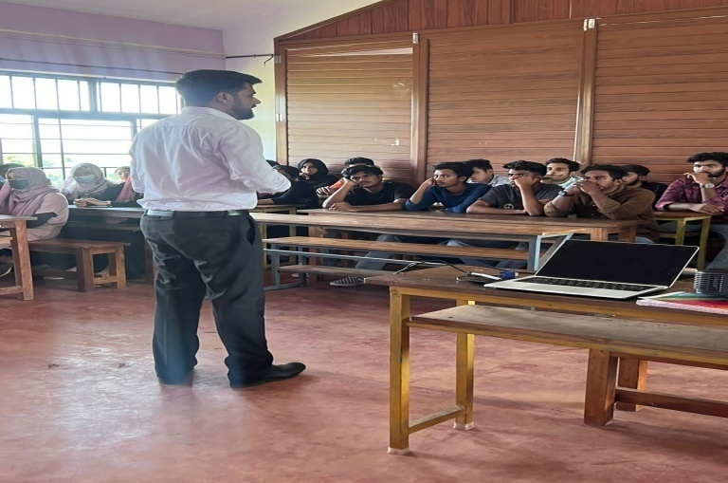

A career guidance session was organised by the department for the final year batch 20/04/22. The session was handled by Dr. Jeryy John, HOD One School of Business, Bangalore.

* 1. ***STUDENTS PROGRESSION***

1. ***HIGHER STUDIES***

Three students of 2018-2021 batches have joined foreign universities for higher studies.

|  |  |  |  |
| --- | --- | --- | --- |
| **Sl No:** | **Name of the Student** | **Course** | **College** |
| 1. | Jerin Julian Goveas | General MBA | University of North Ampton, England |
| 2. | Anagha M K |
| 3. | Muh Fawas | MBA- Supply Chain Management. | university of East London Dockland Campus, University way London |

1. ***CLASS PTA MEETING***

|  |  |  |
| --- | --- | --- |
| **SEMESTER** | **DATE** | **PLATFORM/ MODE** |
| III | 08/01/22 | Google Meet |
| IV | 23/02/22 | Offline |
| V | 29/10/22 | Zoom |
| VI | 05/05/22 | Google Meet |

Parents Teachers Meetings are held at each semester to review the activities of students and seek parent’s feedback. From I BBA batch, **Mrs. Sumayya Basheer**, parent of Fidha Basheer and **Mr. Rajeev P.K**, parent of Adithya Rajeev were selected as PTA representatives.

* 1. **STUDENT PARTICIPATION AND ACTIVITIES**

1. ***ADD ON COURSE***

The principal signed an **MOU** with **ISDC Projects India Pvt.Ltd** - *Add on course* **CMA on** 11/01/22.and the classes commenced from 08/02/22 onwards. Five students have enrolled for the course.

* Khadeejath Shamreena ( II BBA)
* Riya Maniyan ( II BBA)
* Fathimath Nada ( II BBA)
* Adithya Rajeev ( I BBA)
* Fathimathul Safa ( II BBA)

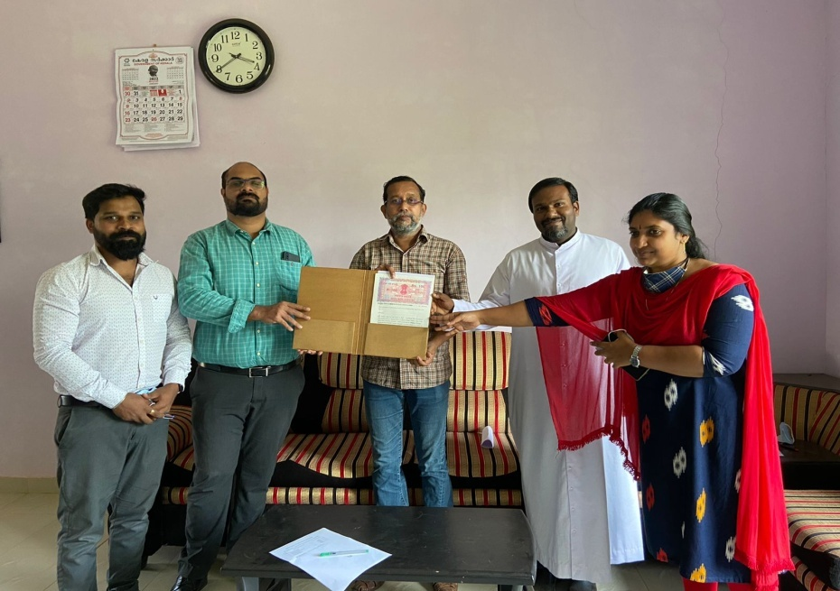

1. ***OTHER PARTICIPATION***

* **Abdul Vahid & Fathimath Nidha** of **III BBA (2019-2022 Batch)** attended Webinar “How to start a start up on 04/06/22
* **Anamika Janardhanan** of **III BBA (2019-2022 Batch)** completed online diploma in “Business management and administration” – Alison Learner Record
* **Suhaila AEP** of **III BBA (2019-2022 Batch)** Participated in Pencil drawing competition on the topic world war with corona on 25/06/21 organized by the **Unnat Bharat Abhiyan Cell, Ahalya School of engineering and Technology, Palakkad**
* **Sankeerth Shaji , II BBA (2020-2023 Batch)** Secured Second position in “Virtual Singing competition organized by Nest College , Payyannur

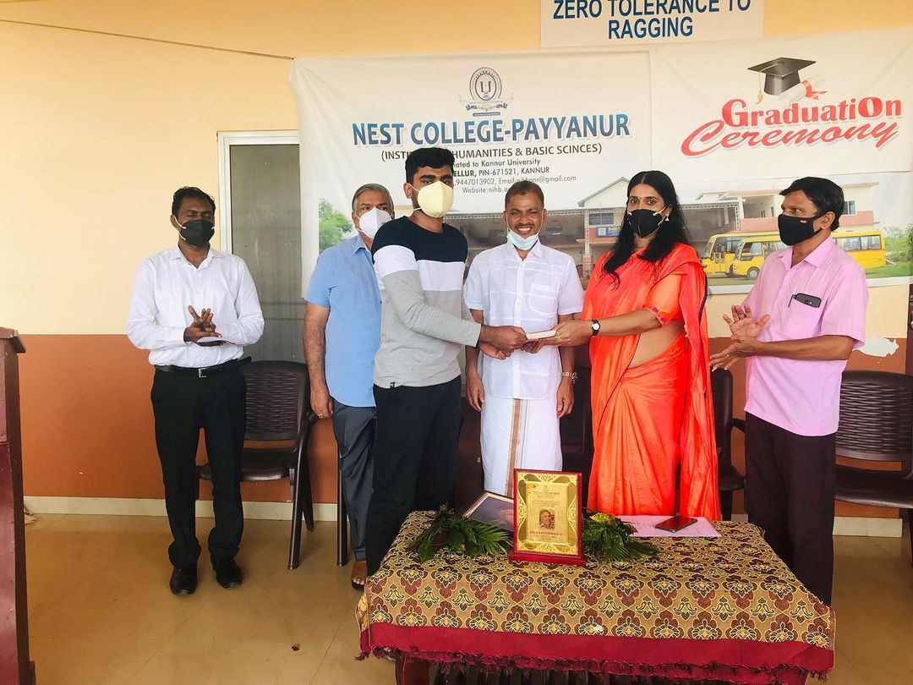

* **Amal Mathew , Anto James & Roshna** of **I BBA (2021-2024 Batch)** have registered in “Young Innovators Program(YIP) by Kerala Development and Innovation Strategic Council

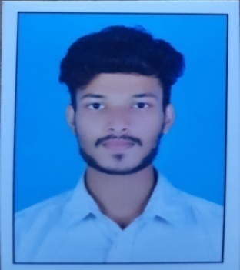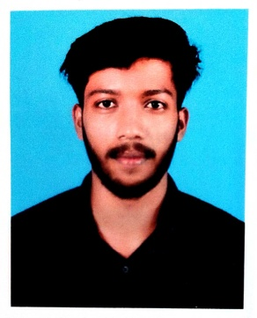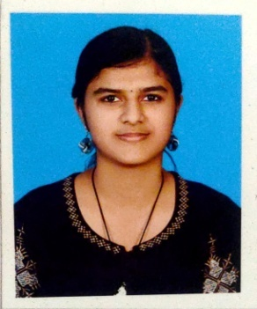

* **Muhammed Saheer I BBA (2021-2024 Batch)** utilized Christmas vacation for travelling from Kasargode to Kanyakumari by Bicycle .He took 5 days to reach the destination.

1. ***SPORTS***

Our students participated in the following items:

* **C**ollege **C**ricket **T**eam : Mohammed Halfaz, Junaid , Moh Afsal and Muhammed AT(III BBA), Haseeb (I BBA)
* **C**ollege **F**ootball **T**eam : Aflah and Ansab (II BBA)
* **B**adminton **M**en : Junaid and Moh Afsal(III BBA)
* **B**adminton **W**omen : Fidha Basheeer (I BBA)

1. ***KALOTHSAVAM – 22***

* Sabin VP participated in English drama(II A Grade)

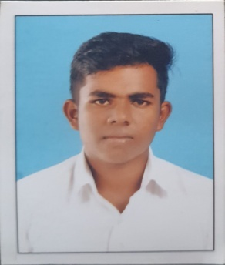

* Muhammed Ameen participated in Hindi Drama (III A grade)

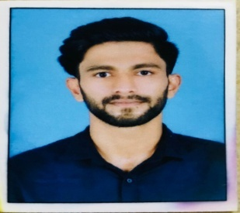

* Gopika P II BBA , Fidha I BBA, Greeshma I BBA participated in Oppana (II A Grade)

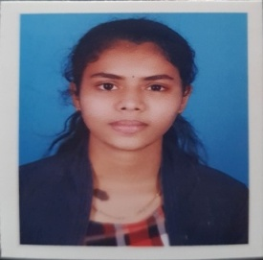 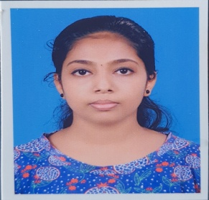

Gopika Greeshma

* Greeshma I BBA participated in Group dance (II A grade)



***OTHER PARTICIPANTS IN KALOTHSAVAM***

* Sankeerth Shaji – Light music solo&

- Malayalam poem

* Fathima Asaraf – Embroidery
* Amal Mathew – Group dance
* Anto James – Group dance
* Jishnu M V – Group dance

1. Yadhukrishnan – Duff Muttu
2. Irfad – Duff Muttu
3. Halfaz – Duff Muttu
4. ***NSS VOLUNTEERS***

|  |  |  |  |
| --- | --- | --- | --- |
| SL NO: | I BBA | II BBA | III BBA |
| 1 | Abu Thahir | Anusree | Anamika Janardhanan |
| 2 | Afrah Mahmood | Irfan B | Abdul Vahid |
| 3 | Bhavana | - | Ameen |
| 4 | Hisana | - | Moh Afsal |
| 5 | Midlaj | - | - |
| 6 | Nadha | - | - |
| 7 | Nanditha | - | - |
| 8 | Nihal | - | - |
| 9 | Ramziya | - | - |
| 10 | Roshna | - | - |
| 11 | Shaziya | - | - |
| 12 | Suhail | - | - |
| 13 | Fidha | - | - |

1. ***COLLEGE UNION BEARERS***

* Abdul Vahid (III BBA) - Chairman
* Muhammed A T(III BBA) - Fine Arts Secretary
* Jinson OP (III BBA) - General Secretary

1. ***BLOOD DONORS***

|  |  |  |  |
| --- | --- | --- | --- |
| **Sl No:** | **I BBA** | **II BBA** | **III BBA** |
| 1 | Shaheer | Shamreena | Abdul Vahid |
| 2 | - | Shamil | Moh Afsal |
| 3 | - | - | Irfad |
| 4 | - | - | Ameen T P |
| 5 | - | - | Moh Salih |

PHOTO GALLERY

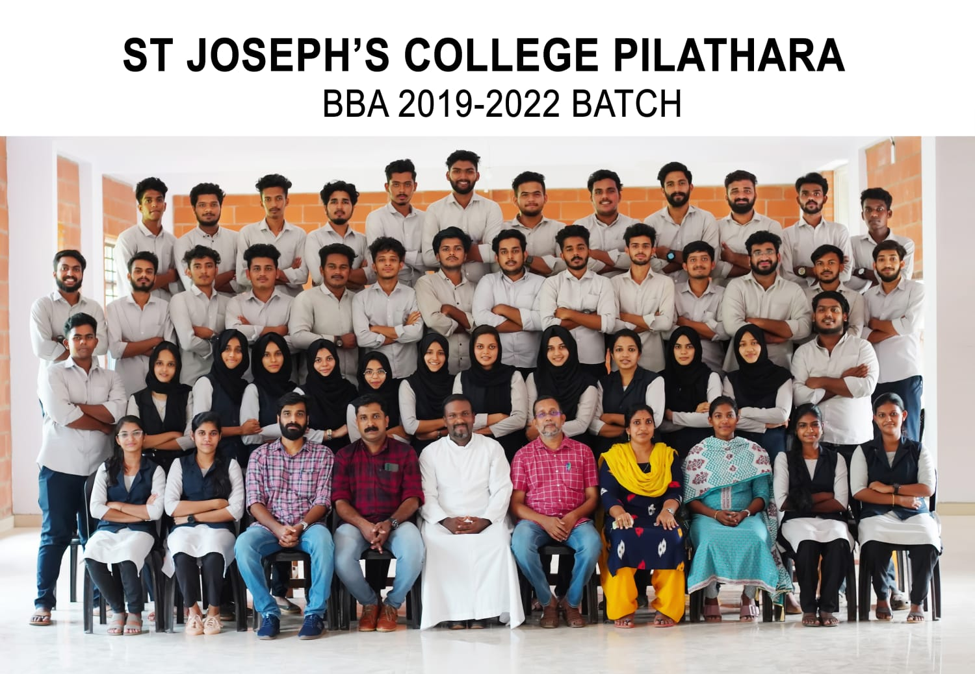

**ENTREPRENEURSHIP AWARENESS PROGRAM**

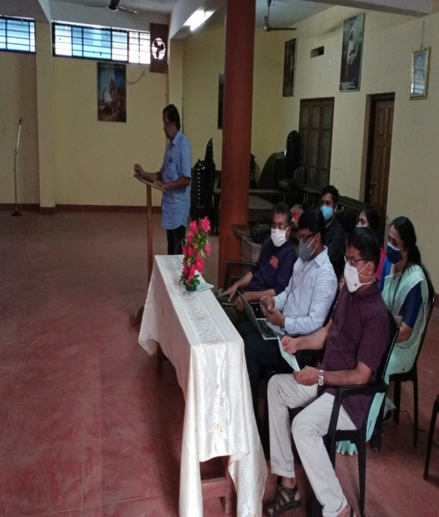 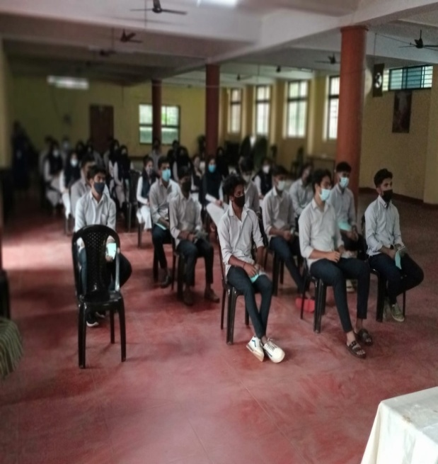

**PADAVU WORKSHOP**

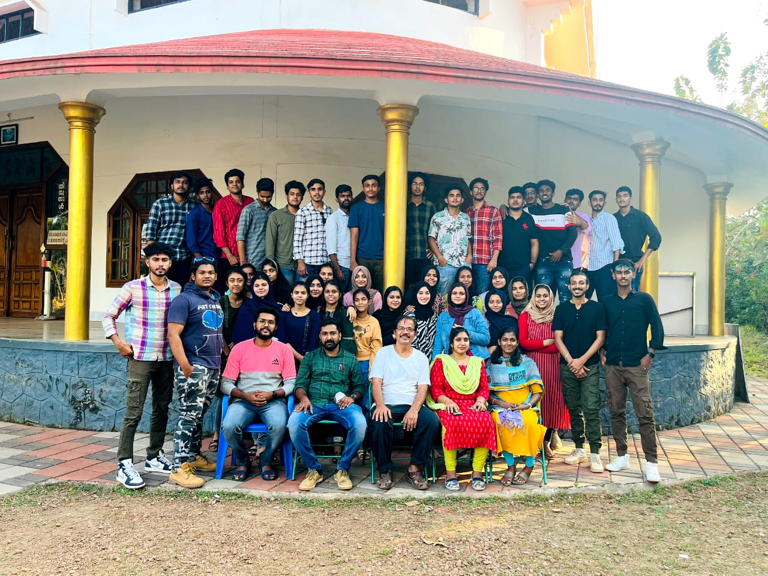

**STUDY TOUR 2019-2022 BATCH**

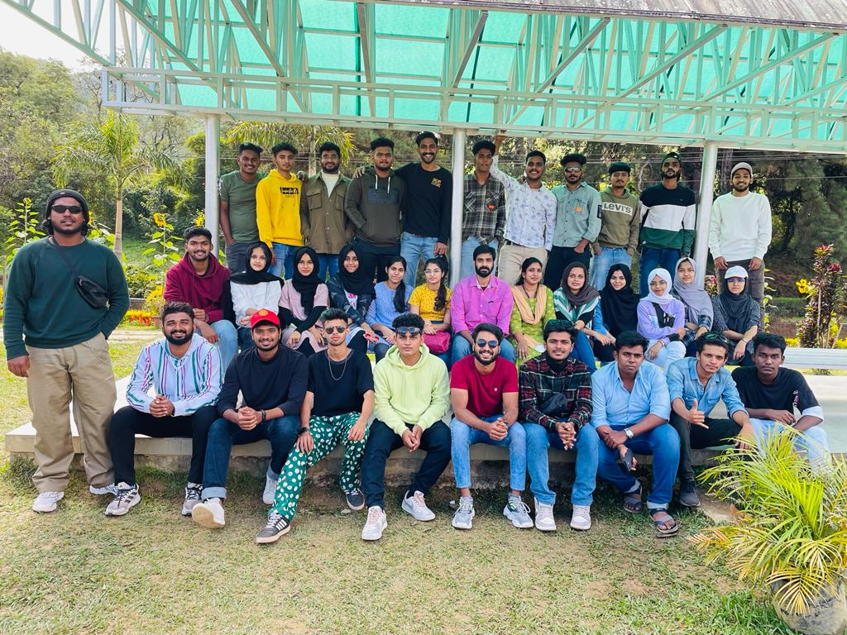

**INDUSTRIAL VISIT – MIZONE**

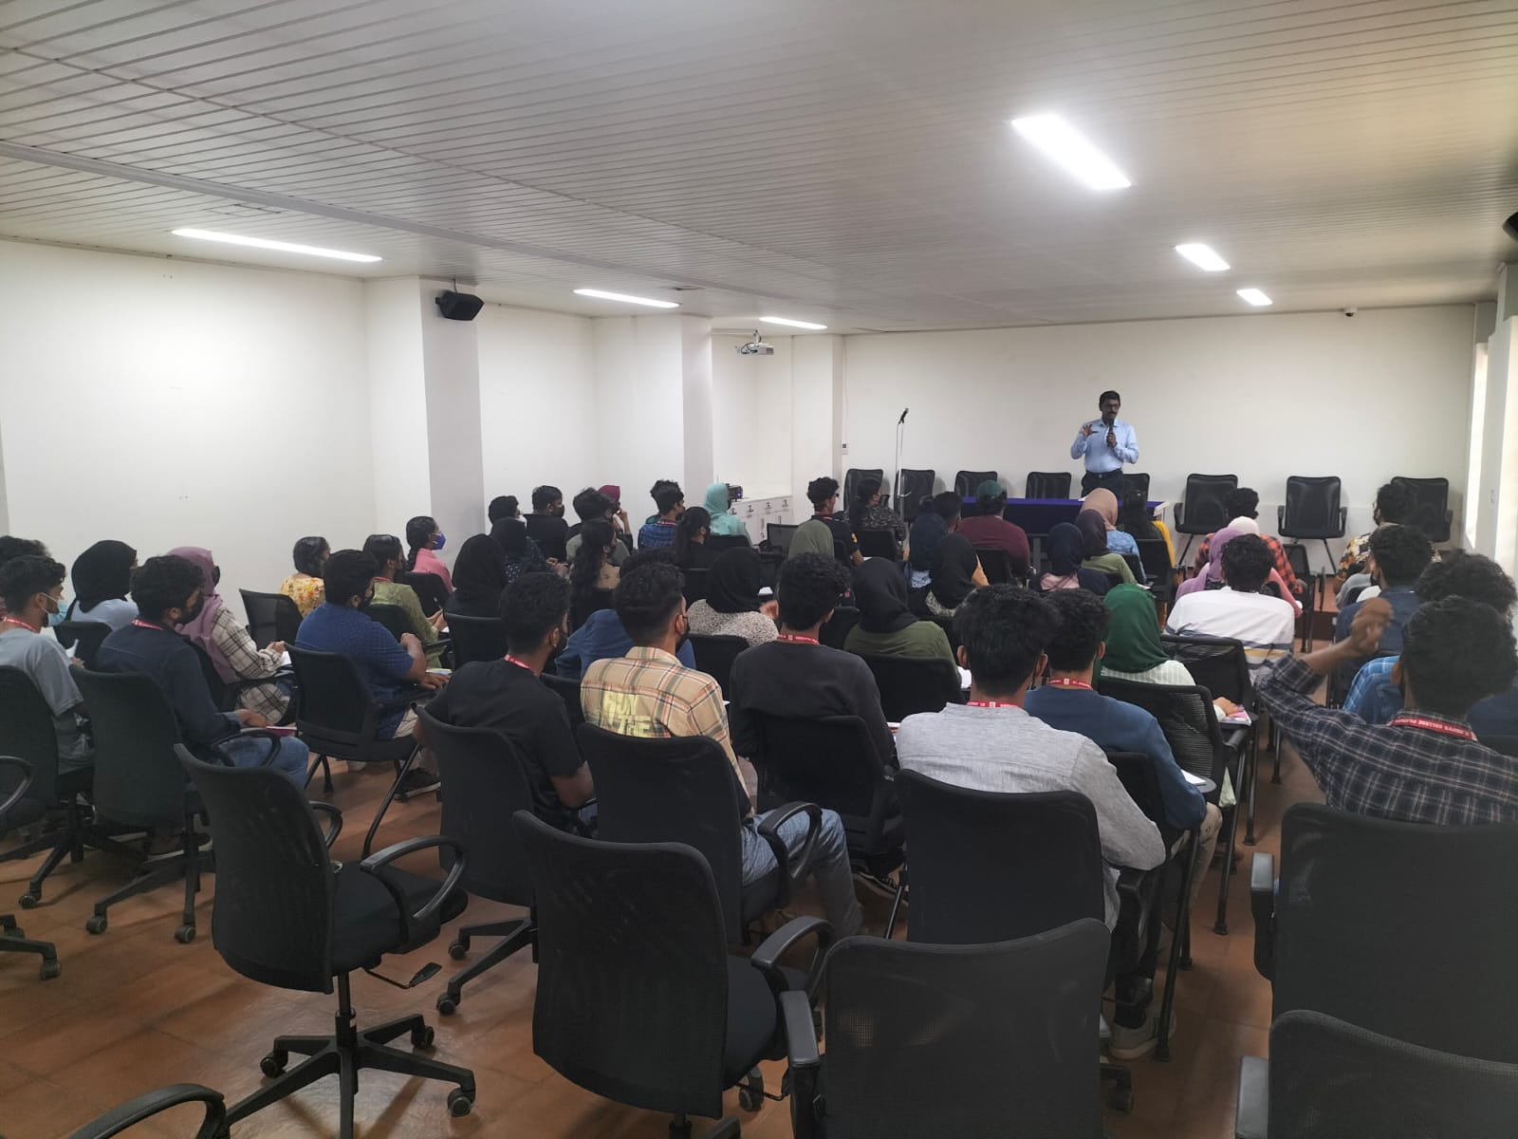

**WORK OF *ANTO JAMES***

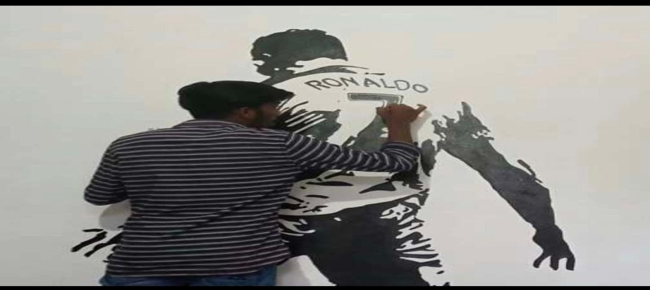

***FATHIMA ASHRAF’s Creative work***

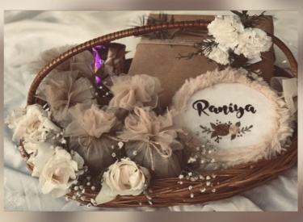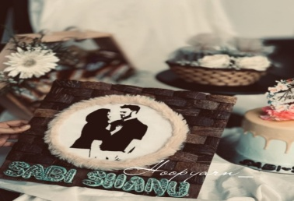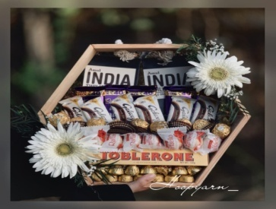

**FAREWELL 2022**

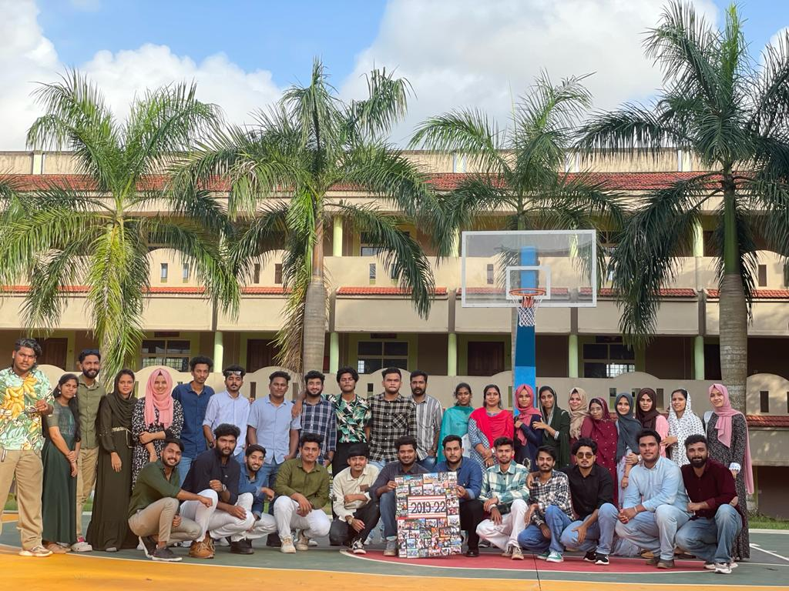

**FOOD FEST**

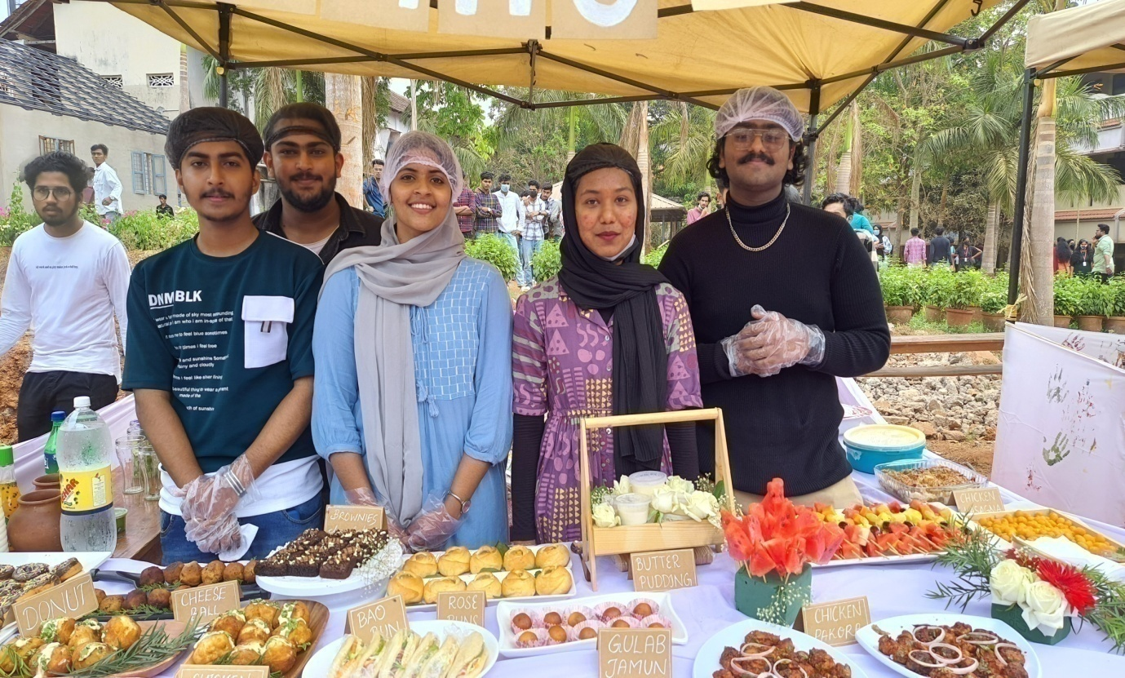

**PTA MEETING**

