**DEPARTMENT OF MANAGEMENT STUDIES**

**EVALUATION REPORT 2020-2021**

**FACULTIES**

* M GREESHMA PAVITHRAN- HOD
* SANGEETH K - TUTOR ( II BBA )
* HARITHA RAJEEVAN - TUTOR ( I BBA )
* VINIL P VISWANATH - TUTOR ( III BBA )

With the Covid Pandemic continuing its surge, the new academic year 2020-2021 commenced in the online mode. Even the new batch – I BBA was admitted in the month of November which was supposed to be in August. All classes were held in digital platform, such as Zoom, Google Meet, Webex meet etc. And all of us adapted to the novel teaching learning settings with the pass of time.

There were 118 students initially. However due to 4 drop outs in II BBA, 1 drop out in III BBA and 1 readmission in III BBA, currently the Department is managing 114 students – 48 girls and 66 boys.

**CURRICULAR ENRICHMENT**

Session On:

* **“Resume Preparation”**  - III BBA 2018-2021Batch : Vinil Vishwanath ( Dept Faculty) 21/08/20
* **“How to Register in Different job portals”** - II BBA 2019-2022Batch : Vinil Vishwanath ( Dept Faculty) 31/03/21
* **“ How to Crack in Interview”** – III BBA 2018-2021 Batch : Sangeeth ( Dept Faculty) 09/04/21

**TEACHING LEARNING**

* College level and Department level Orientation session was conducted for 1st Semester students and parents on 05/11/20
* Post Entry Test was conducted for I BBA batch on 25 /11/2020
* Bridge Course started for I BBA from 26/11/20 to 31/12/20
* Online classes structure – 3 live classes + 2 offline classes
* Separate Google Classrooms for each paper for uploading study materials.
* **“Awareness on Stock Market Index and Investment”** – III BBA 2018-2021 Batch : Sangeeth K ( Dept Faculty) 19/01/21
* **“Dining & Telephone Etiquette”** II BBA 2019-2022Batch : Vinil Vishwanath ( Dept Faculty) 20/01/21
* **“Impact of Advertisement in Daily Human Life”** – I BBA 2020-2021 Batch : Sangeeth K ( Dept Faculty) 10/05/21
* **Remedial Coaching Classes**
* 8 Students were selected from the final year batch that required special help and attention.
* These students were divided among the Faculties for monitoring their status and progress.
* A special Google classroom created for uploading material and giving assignments.
* Teachers monitored their work and gave feedback accordingly
* Out of the 8 Students, 07 passed in the 6th semester examination
* Short Term Online Courses Orientation - **AVODHA**
* **DEPARTMENT MEETING**

|  |  |  |
| --- | --- | --- |
| **Sl.No:** | **Date & Time** | **Platform** |
| 1 | 27/06/20 - 10am to 11am | Zoom |
| 2 | 05/07/20 - 10am to 11am | Zoom |
| 3 | 12/07/20 - 9pm to 9:45pm | Zoom |
| 4 | 22/07/20 - 9pm to 10pm | Zoom |
| 5 | 24/07/20 - 2:30pm to 3pm | Zoom |
| 6 | 11/08/20 - 12:30pm to 1pm | Zoom |
| 7 | 12/08/20 - 3pm to 3:40pm | Zoom |
| 8 | 08/09/20 - 5pm to 5:50pm | Zoom |
| 9 | 12/09/20 - 7:30pm to 8:10pm | Zoom |
| 10 | 24/09/20 - 5:40pm to 6:15pm | Zoom |
| 11 | 3/10/20 - 8pm to 8:45pm | Zoom |
| 12 | 10/10/20-11am to 12:30pm | Zoom |
| 13 | 14/10/20 -11am to 12:30pm | Zoom |
| 14 | 09/12/20 - 6pm to 6:45pm | Zoom |
| 15 | 06/01/21- 3pm to 4pm | Zoom |
| 16 | 19/04/21- 7pm to 7:45pm | Zoom |
| 17 | 25/04/21- 4pm to 4:45pm | Zoom |
| 18 | 11/05/21- 3pm to 3:45pm | Zoom |
| 19 | 19/05/21- 4pm to 4:45pm | Zoom |
| 20 | 26/05/21- 3pm to 4pm | Zoom |

**STUDENTS ACHIEVEMENTS’**

Due to the pandemic situation, our students could not showcase their innate talents as expected. However many of the students managed to participate in Online Quiz, Webinars, Online Internship etc.

**Anamika Janardhanan of II BBA** participated sessions on “E- Entrepreneurship” on 24/08/20, “Blockchain: The Next Everything” on 25/08/20, “ Cyber Securities-Secure Yourself First” on 26/08/20, “ Machine Learning & AI – A Gen Tech” on 27/08/20, “IT Tends 2020 – An Experiential Review” on 28/08/20, “ Internet of Things – Things made Easy” on 29/08/20, “Technology and Environment” on 30/08/20 organised by Prestige Institute of Management Research

**Internship:**

* Business Research – 31/08/20 to 20/09/20 : Scoar, Kolkata
* Social Media Marketing – 01/10/20 to 31/03/21: Ferofly, Delhi

**Anaswara of III BBA** anchored Annual day programme of Lasya College of Fine Arts on 02/10/20

* **Online Quiz on Entrepreneurship by Govt College Thripunithara on 21/08/20**
  + - Jerin Julian Goveas III BBA
    - Abdul Vahid II BBA
    - Rejo Jelin II BBA
    - Ashwin M K II BBA
    - Vijith Vijayan II BBA
    - Navaneeth Jay II BBA
    - Theertha T II BBA
    - Anamika Janardhanan II BBA
    - Suhaila K P II BBA
    - Aiswarya Mohanan II BBA
    - Shyamapriya II BBA
* **Online Quiz on Entrepreneurship by T.K.M College of Arts & Science, Kollam on 21/08/21**
* Vijith Vijayan II BBA
* Rejo Jelin II BBA
* **Webinar**

**“IKIGAI for Industry 4.0: Purpose, Profit and Preparing for the Future of** **Work”** by Lourdes Matha Institute of Management Studies on 22/08/21

* Jerin Julian Goveas III BBA
* Anagha M K III BBA
* Akshay Dinesh II BBA
* Navaneeth Jay II BBA
* Anamika Janardhanan II BBA

**“Financial Education for Young Investors”** by Avinashilingam Institute for Home Science and Higher Education for Women on 17/10/20

* Jerin Julian Goveas III BBA

**“Recent Environmental Emergencies”** by Geneva Environment Secretariat, United Nations Environment Programme on 07/10/20

* Abdul Vahid II BBA
* Anamika Janardhanan II BBA

**“Wealth Management as Career”** by Hedge School of Applied Economics on 16/09/20

* Jerin Julian Goveas III BBA

**“Project Report Preparation”** by MES Kalladi College Mannarkkad on 19/10/20

* Jerin Julian Goveas III BBA
* Anagha M K III BBA
* Anamika Janardhanan II BBA

**“Why Skill Education” by Institute of Gems &Jewellery** on 15/10/20

* Jerin Julian Goveas III BBA

**“Fundamentals of Intellectual Property Rights”** by MES Kalladi College, Mannarkkad on 23/10/20

* Jerin Julian Goveas III BBA
* Anagha M K III BBA
* **Part time Job**
* Anagha M K worked with Ansedd Authorised Distributor – Manjeri as a Freelance Telemarker from 1/10/20 to 31/05/21
* Ananamika Janardhanan worked with Maaxus Mini Hub, Mandoor from 01/01/21 to 28/02/21
* **Sports Stars**
* **C**ollege **F**ootball **T**eam - Nihal VV (III BBA), Muh Bilal (III BBA),Moh Shaheen Abbas (II BBA), Moh Halfaz (II BBA), Junaid (II BBA), Moh Muzammil Rahman (II BBA)
* **C**ollege **C**ricket **T**eam – Moh Halfaz (II BBA), Junaid (II BBA), Moh Shaheen Abbas (II BBA), Muh Mustafa (II BBA)
* **Nihal V V** of III BBA was selected to Kannur University Football Team

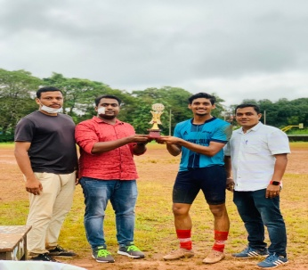

* **NSS Office Bearers**
* Abdul Vahid - **S**ecretary
* Anamika Janardhanan - **R**eporter

**STUDENT’S CONTRIBUTION**

* **Blood donors** of the department include: Muhammed Favas & Nihal VV from III BBA, Muhammed Afsal , Irfad Ibrahim, Abdul Musawir, Muhammed Ameen & Muhammed Shaheen Abbas, Anshad from II BBA
* **A**namika **J**anardhanan of II BBA holds the position of **C**ampus **W**ing **G**eneral **S**ecretary- **Blood Donors Kerala , Payyannur Taluk**

**MEGA EVENT**

To utilize this pandemic period, the Department of Management Studies in collaboration with Entrepreneurship development club, St. Joseph’s College, Pilathara attempted to host its debut webinar “THE NEO NORMAL ENTREPRENEUR” on the topic “How to become a digital entrepreneur in the post covid era” on **22/09/20**. The webinar aims to develop awareness on changes in entrepreneurial practice. The session also intends to motivate, encourage and develop the new and existing entrepreneurs towards digitalization. The session was handled by Dr. K.P Najeemudheen- Professor, Writer and Corporate Mentor.

The webinar was inaugurated by our College Patron Rt. Rev. Dr. Alex Vadakumthala – Bishop, Kannur Diocese. There were 164 participants, and the webinar turned out to be a great success, as every student who attended expressed their feedback which suggests that the initiative taken has turned to be fruitful.

**RESULT ANALYSIS**

In the academic year 2020-2021, 23 students (10 girls and 14 boys) appeared for the exam, out of which 31 attendees, 8 girls and 2 boys cleared the BBA degree with pass percentage of **41.60%** (10/24).

**Sherin Jalal** and **Jerin Julian Goveas** were the class toppers with 86% and 82% respectively.

**PTA**

Parents Teachers Meetings are held at each semester to review the activities of students and seek parent’s feedback. From I BBA batch, **Mrs. V V Preetha**, parent of Dheeraj and **Mr. K Shaji**, parent of Sankeerth Shaji were selected as PTA representatives.

|  |  |  |
| --- | --- | --- |
| **SEMESTER** | **DATE** | **PLATFORM** |
| I | 05/11/20 | Zoom |
| II | 30/05/21 | Zoom |
| III | 06/06/19, 06/08/21 | Zoom |
| IV | 16/05/21 | Zoom |
| V | 31/05/20, 19/07/20 | Zoom |
| VI | 09/05/21 | Zoom |

**TEACHER PROFILE AND QUALITY**

**M.GREESHMA PAVITHRAN**

* Participated in two day Online Workshop on **“Creation of Instructional** **Videos and Recording”** organized by IQAC, NSS College Pandalam on 13th and 14th May 2020
* Participated in National Webinar on **“The New Normal in Education”** organized by IQAC, St.Albert’s College (Autonomous) on 23rd May 2020
* Participated in the 5 day Faculty Development Programme, **“How Can Teachers Make a Difference”** by Teaching Learning Centre, IIT Madras, organized by IQAC Sree Sankara College, Kalady from 26th May to 30th May 2020
* Joined Short term online course - **STUDENT PSYCHOLOGY** through **SWAYAM** platform 20/07/20
* Participated in Webinar on **“National Education Policy 2020 and issues on Accreditation”** organised by IQAC Nehru Arts and Science College, Kanhanagad on 27/08/20
* Participated in Online Workshop on **“Rural Entrepreneurship Development Action Plan”** organised by Mahatma Gandhi National Council of Rural Education, Hyderabad on 24/09/20
* Participated in Workshop on **“Tricks and Trades in writing Research Papers”** organised by Institute of Gems & Jewellery on 27/05/21

**VINIL P VISWANATH**

* **ED Club in charge**
* Participated in Online Workshop on **“Rural Entrepreneurship Development Action Plan”** organised by Mahatma Gandhi National Council of Rural Education, Hyderabad on 24/09/20
* Participated in National Webinar **“Tourism Business Renaissance in Post Covid Scenario”** organised by NAM College, Kallikkandy on 15/10/20
* Participated in Webinar **“Why Skill Education”** organised by Institute of Gems & Jewellery on 15/10/20
* Participated in National Webinar **“E-Commerce : The Changing Face of Retail in India”** organised by Mercy College, Palakkad on 16/10/20
* Participated in Webinar on **“Financial Education for Young Investors”** by Avinashilingam Institute for Home Science and Higher Education for Women on 17/10/20

**PHOTO GALLERY**

**Jumana - BBA Alumni 2017-2020 Batch**

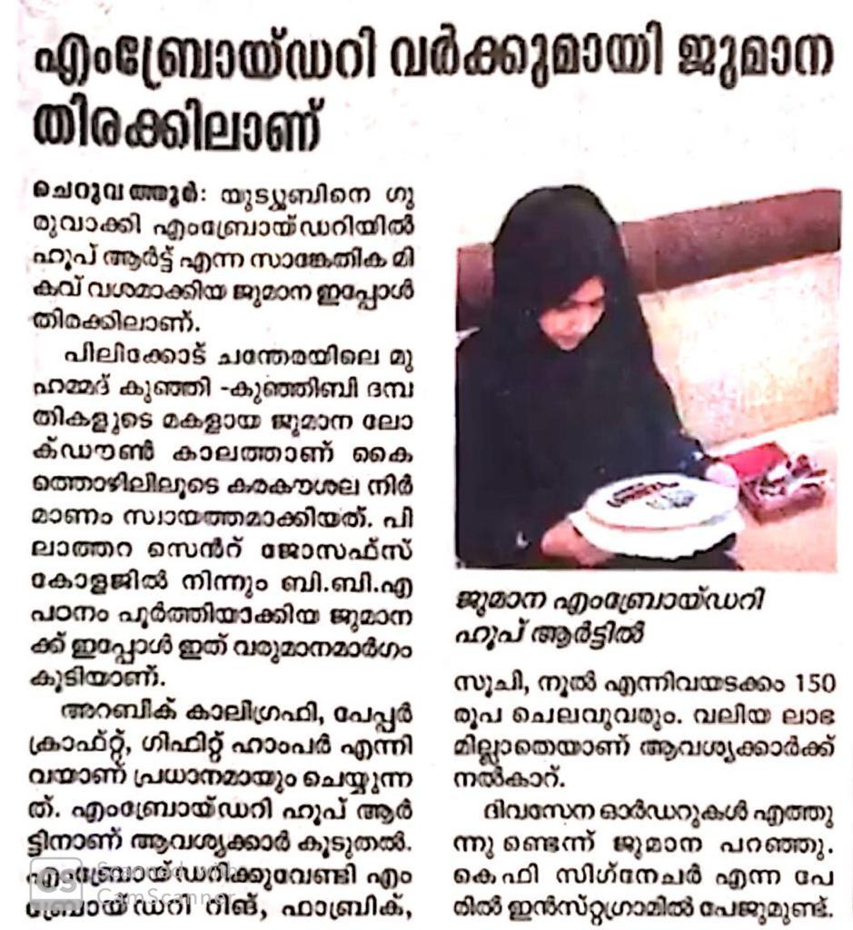

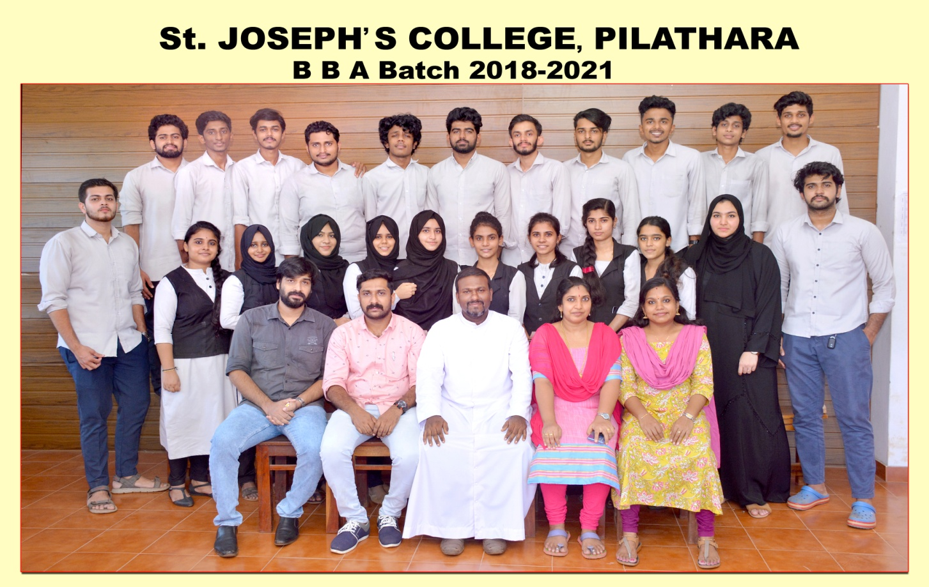

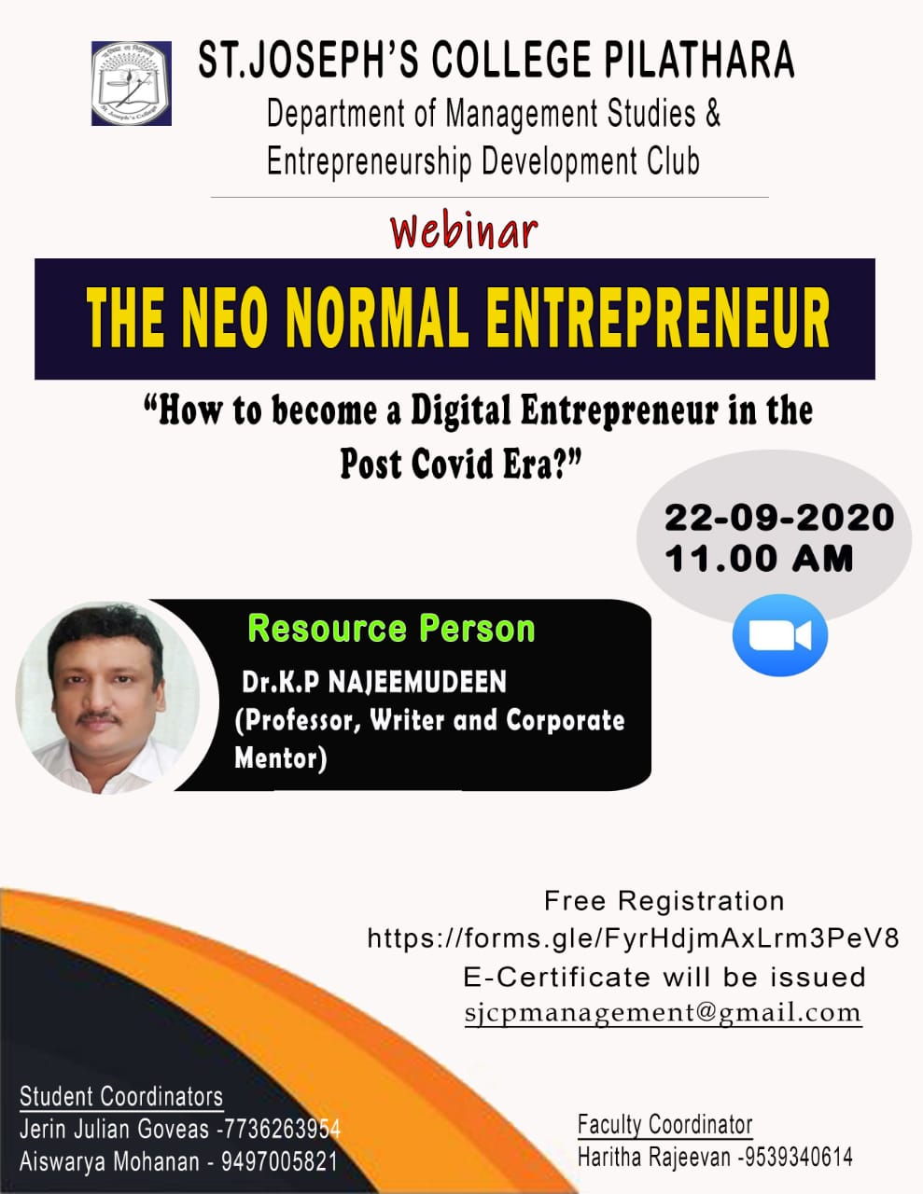

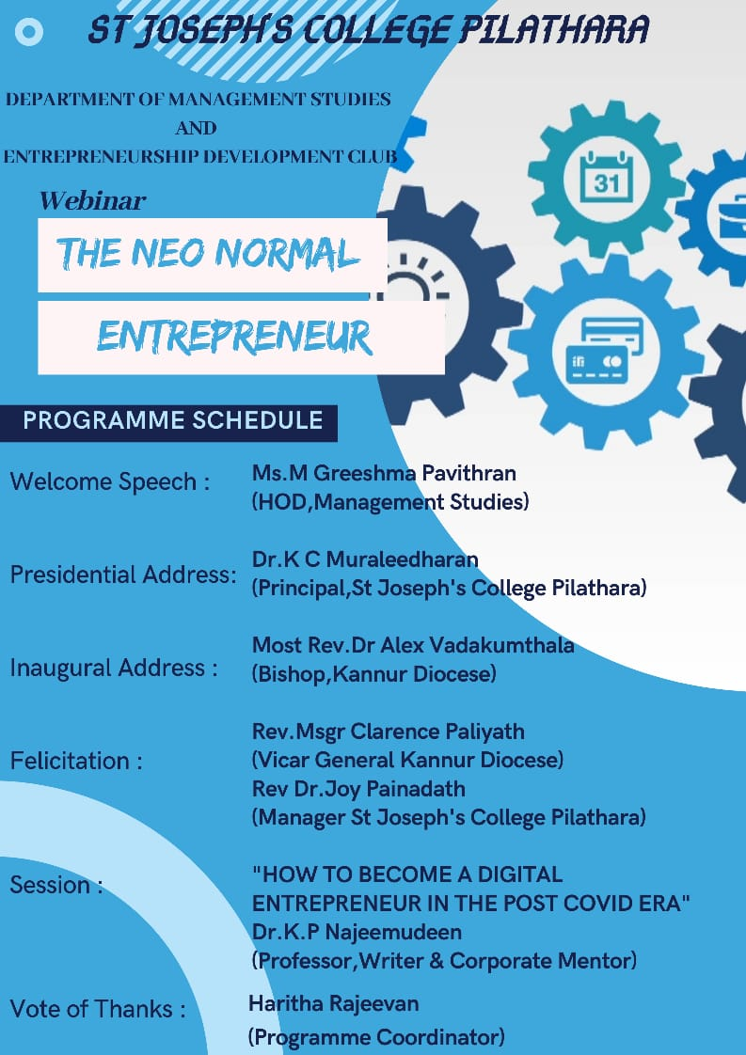

**Webinar Participants**

