DEPARTMENT OF MANAGEMENT STUDIES
EVALUATION REPORT 2018- 2019
FACULTIES
- M GREESHMA PAVITHRAN- HOD
- SANGEETH K
- HARITHA RAJEEVAN
- VINIL P VISWANATH
In 2018-2019, the Department of Management Studies experienced a year of significant progress, as the teachers put their full potential to meet the needs of the students. The data we collected show improvement in number of aspects such as maintaining stable attendance, academic results. We are aware of our challenges and opportunities for further development. We are committed in making difference.
The academic year 2018-19 commenced on 5th June 2018. There was an enrolment of 30 students in 1st BBA batch. Thus the current year, the department consists of 95 students initially, however due to drop out of 2 students in III BBA, one each in II BBA and I BBA and a new admission in II BBA, towards the end, the department comprises of 92 students-49 boys and 43 girls. The department introduced formal wear- suits for the 1st year batch. The HOD Ms Minu Mary Joseph resigned and Ms Greeshma Pavithran from Commerce Dept took charge on 05/06/2018. One of the faculties Ms Remya R Nambiar resigned on 22/11/18 and Mr Vinil P Viswanath replaced the post on 10/12/18.
CURRICULAR ENRICHMENT
- On 8th June 2018, the department organised Motivation and Personality Development session by college Librarian Mr. Vijay Sangeeth for II BBA and III BBA students
- On 2nd Aug 2018, II BBA students attended a motivation class given by our former Principal Msgr. Clarence Palliath Vicar General Kannur Diocese
- The department commenced their add on course Tally ERP 9.0 & communicative English course in collaboration with Synergy School of Business Skills on 3rd sep 2018, for II BBA and I BBA batches
- The department initiated one day picnic to wayanad for final year students on 2nd Feb 2019 accompanied by Sangeeth K and Haritha Rajeevan
- The department arranged Padavu Workshop for II BBA batch led by Mr Prakashan Padiyil & Mr Raghunath
- Career Guidance session for final year students on 22nd Feb. 2019,by Sulifikar Aly P.K, motivational speaker and founder of Sulfi Inspires
TEACHING LEARNING
- on 15th aug 2018, a session on Legal Aspects of Business was handled by Advocate Ravi for III BBA & II BBA batch
- 4th SEM Remedial coaching by Mr.Vinod Commerce department on 21.03.19
- Post entry test was conducted for I BBA batch on 10-10-2018
- On 5th Nov 2018, the department organised a session on Research Methodology by Dr. P I Laila, HOD ,Commerce, St.Joseph’s College , Pilathara
- As a part of curriculum, dept initiated an Industrial Visit for II BBA batch on 19/01/19 to Western India Plywood, Valapattanam
STUDENTS ACHIEVEMENTS’
- Marwa Ahamed of III BBA secured 80% in university exam
- Sarath Satheeshan of III BBA won the best actor award in Hindi drama and Moh Shahbas and Moh Arshad of II BBA participated in Duff competition in University Kalotsavam held at Kanhanagad.
- Sherin Haneef, Anagha M K and Jerin Julian Goveas of I BBA participated in a business meet organised by Kaithapram Podujana Vayanashala & Grandalayam held at Kaithapram on 13/10/2018 .
- Wafa Moideen (III BBA) and Sahal Ismayil (II BBA) ,were elected as Joint Secretary and Fine Arts Secretary in College Union
- The blood donors of the department include Sarang Manohar, Sahal Ismayil, Muhammed Mubashir, Muhammad Abdul Haseeb- II BBA, Safwan T P, and Muhammed Fawas – I BBA
MEGA EVENT
The department attempted in hosting its debut mega event “E N T R E P O T 2K19” an entrepreneur development workshop on 11th Jan 2019 in collaboration with ED club and DIC Kannur. The workshop was inaugurated by Mr Vinod Narayanan, President, Chamber of Commerce. The session handlers were:
- Mr. Sebastian Antony -CEO ,Sakthi Tarpolin
- Mr.Subhash JC -Arto carpus Foods Pvt Ltd
- Mr.Subhash Babu K -Malabar Innovation Handloom
- Mrs.Smitha R K -Industrial Section Officer, DIC Kannur

RESULT ANALYSIS
The academic year 2018- 2019 witnessed hike in pass percentage compared to previous years. Out of 29 attendees, 6 girls and 4 boys cleared the degree: 10/29 (34.4%)

PTA
Parent’s teachers meeting were conducted in each semester so that the Parents could understand and analyse the status of their students. From I BBA batch, Mrs. Anitha A, parent of Sreenitha was selected as PTA representative.
SEMESTER | DATE
I | 18/10/18
II | 19/02/19
III | 04/08/18
IV | 14/02/19
V | 27/07/18
VI | 12/02/19

TEACHER PROFILE AND QUALITY
Ms. M Greeshma Pavithran attended two day national seminar on “financial derivatives – basics and application” held at Govindapai Memorial Govt. College, Manjeshwaram on 14th and 15th Sep 2018

PHOTO GALLERY
ENTREPOT 2K19
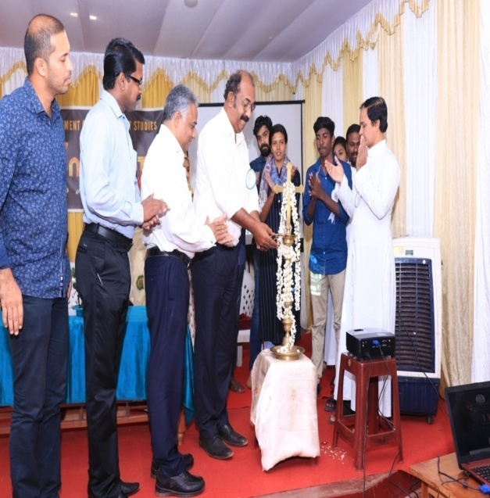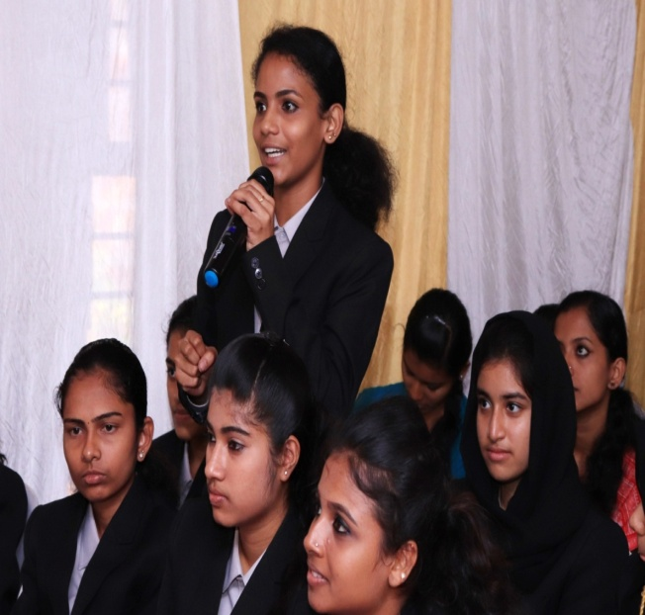

PADAVU WORKSHOP

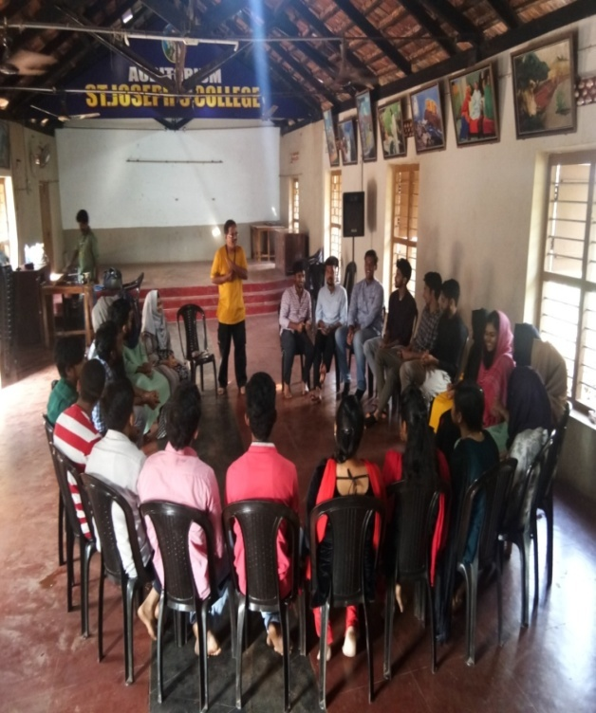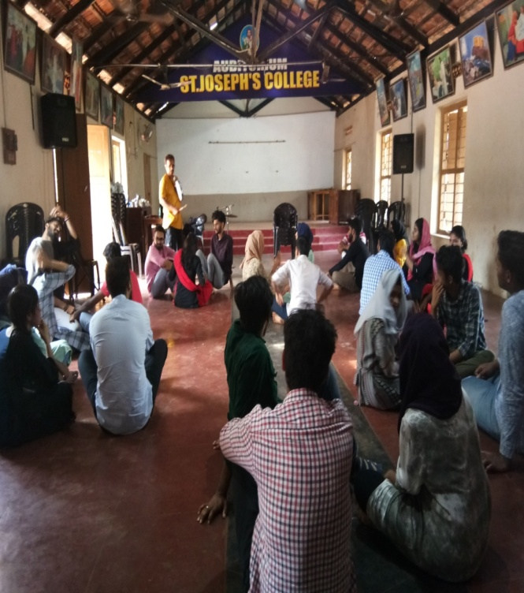

2016-2019 BATCH
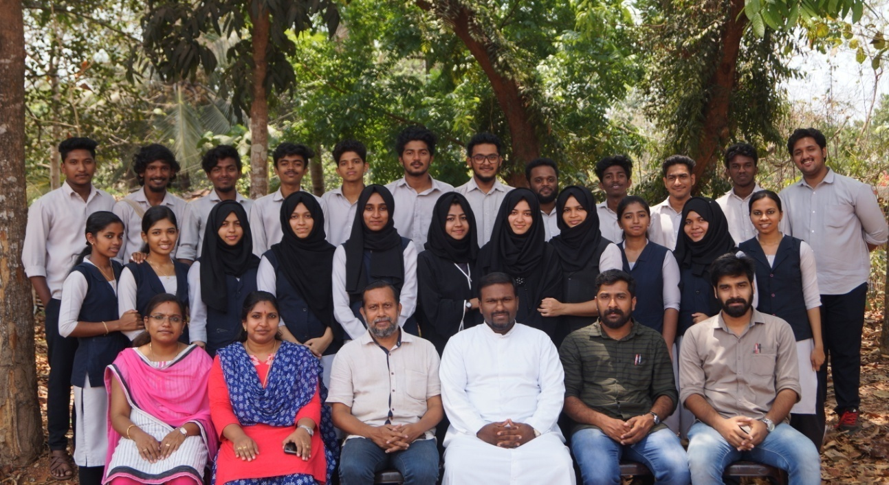
INDUSTRIAL VISIT
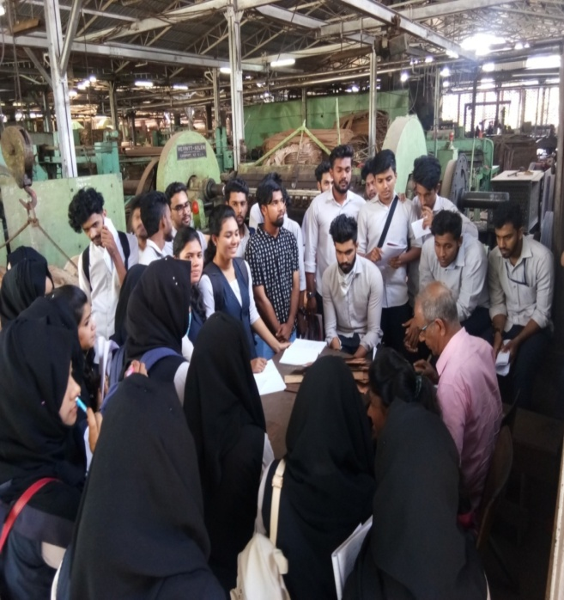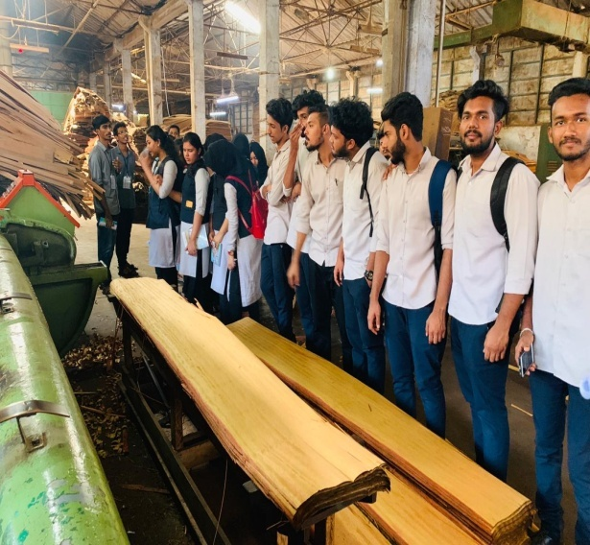

Session on “LEGAL ASPECTS OF BUSINESS “ ONE DAY OUTING- WAYANAD- FINAL YEAR 